DJANGO

Conventions

>> refers to command

—> refers to output

text to be replaced when enough knowledge is studied later

**\*\*\*\*\*\*\*\*\*\*\*\*\*\*\*\*\*\*\*\*\*\*\*\*\*\*\*\*\* Django Level 1 - Basics \*\*\*\*\*\*\*\*\*\*\*\*\*\*\*\*\*\*\*\*\*\*\*\*\*\*\*\*\*\***

**\*\*\*\*\*\*\*\*\*\*\*\*\*\*\*\*\*\*\*\*\*\*\*\*\*\*\*\*\*\*\*\*\*\*\*\*\*\*\*\*\*\*\*\*\*\*\*\*\*\*\*\*\*\*\*\*\*\*\*\*\*\*\*\*\*\*\*\*\*\*\*\*\*\*\*\*\*\*\*\*\*\*\*\*\*\*\*\***

# Django Level 1 - Part 1 - Django Setup

* Django is a free and open source web framework.
* It is used by many sites, including Pinterest, PBS, Instagram, BitBucket, Washington Times, Mozilla, and more!

**Virtual Environment**

A virtual environment allows you to have a virtual installation of Python and packages on your computer. So why would you ever want or need this after already installing python on your system?

* Python Packages change and get updated often!
* There are changes that break backwards compatibility.
* So what do you do if you want to test out new features but not break your web app?

A virtual environment is a tool that helps to keep dependencies required by different projects separate by creating isolated python virtual environments for them. This is one of the most important tools that most of the Python developers use.

**Why do we need a virtual environment?**

Imagine a scenario where you are working on two web based python projects and one of them uses a Django 1.9 and the other uses Django 1.10 and so on. In such situations virtual environment can be really useful to maintain dependencies of both the projects.

**When and where to use a virtual environment?**

By default, every project on your system will use these same directories to store and retrieve site packages (third party libraries). How does this matter? Now, in the above example of two projects, you have two versions of Django. This is a real problem for Python since it can’t differentiate between versions in the “site-packages” directory. So both v1.9 and v1.10 would reside in the same directory with the same name. This is where virtual environments come into play. To solve this problem, we just need to create two separate virtual environments for both the projects.The great thing about this is that there are no limits to the number of environments you can have since they’re just directories containing a few scripts.

Virtual Environment should be used whenever you work on any Python based project. It is generally good to have one new virtual environment for every Python based project you work on. So the dependencies of every project are isolated from the system and each other.

**How does a virtual environment work?**

We use a module named **virtualenv** which is a tool to create isolated Python environments. virtualenv creates a folder which contains all the necessary executables to use the packages that a Python project would need.

**Luckily, Anaconda makes this really easy for us!**

**A virtual environment handler is included!**

Install anaconda

## Creating a Virtual Environment

>> conda create --name myDjangoEnv django

here,

*myDjangoEnv: is the name of virtual environment*

*django: is the package we want to use in that environment*

To list all the virtual environments installed on your computer, you can use the following commands

>> conda info --envs

Lets create an virtual environment with python 3.7

>> conda create —name myDjangoEnv python=3.7

After approving the packages to be installed, you will see the window like this

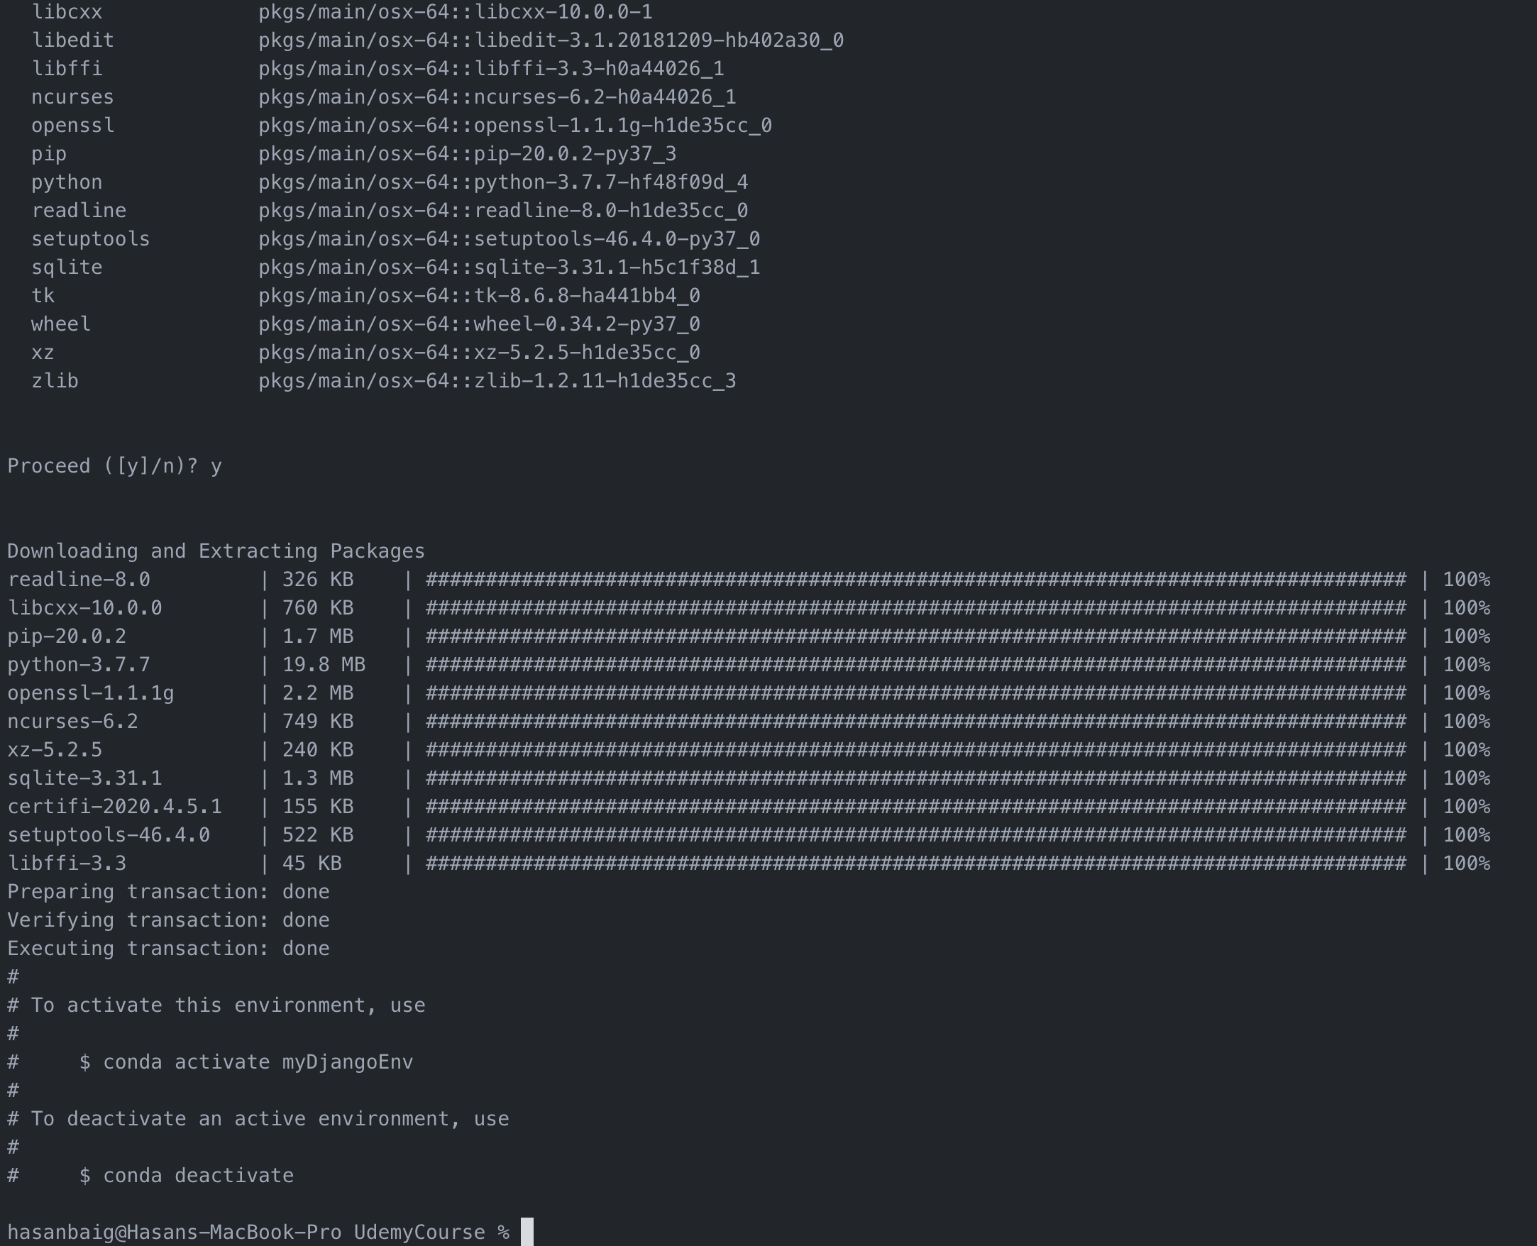

Once the virtual environment is activated using the commands shown in the screen shot, the command line will be suffixed by (environmentName) as shown in the image below:



once the package is activated, whatever package we install, it will be installed inside that virtual environment. for example. install a django package

>> conda install django

# Django Level 1 - Part 2 - Django Project

**Current Working Directory**: /Users/hasanbaig/UdemyCourse/DjangoPythonBootCamp/Django

When you install Django, it actually also installed a command line tool called: django-admin

Let’s create our first project.

## Creating a Django Project

Type:

>> django-admin startproject first_project

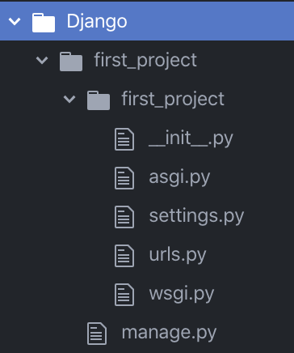

Default files explanation

1. **init__.py**
   * This is a blank Python script that due to its special name let’s Python know that this directory (first_project) can be treated as a package
2. **settings.py**
   * This is where you will store all your project settings
   * In any django project, settings.py is the main configuration file
   * it controls how django interacts with your system and manages the project
3. **urls.py**
   * This is a Python script that will store all the URL patterns for your project. Basically the different pages of your web application.
   * tells django which pages to build in response to browser requests
   * A lot of regular expression will be used in this file
4. **wsgi.py**
   * This is a Python script that acts as the Web Server Gateway Interface. It will later on help us deploy our web app to production
   * it helps in deploying the web on a server and make an interface.
5. **manage.py**
   * This is a Python script that we will use a lot. It will be associated with many commands as we build our web app!

Lets run the server but first make sure that you are in the right directory (in this case, it is first_project).

>> python manage.py runserver



We are seeing this webpage because the option “DEBUG” under settings.py file is set to true. If you turn it to False, you wont be able to see this page, rather will be prompted with the following message..

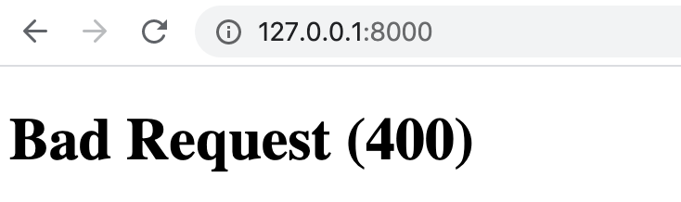

when you run the server, you will see some migration warnings highlighted in red as shown below

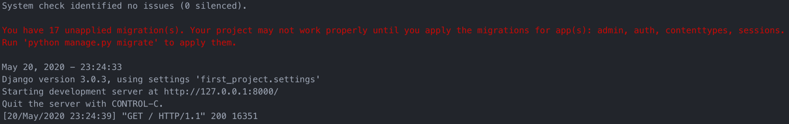

These warnings are linked with the databases and how to connect them to django.

**Migration:**

* A migration allows you to move databases from one design to another, this is also reversible.
* So you can “migrate” your database
* We will touch back on this later, for now you can ignore this warning.

# Django Level 1 - Part 3 - Django Application

So far we have been able to use runserver to test our installation of Django. Now let’s move on to creating our first Django Application. We’ll learn about **views** and how to use them

*A* ***Django Project*** *is a collection of applications and configurations that when combined together will make up the full web application (your complete website running with Django)*

*A* ***Django Application*** *is created to perform a particular functionality for your entire web application. For example you could have a registration app, a polling app, comments app, etc.*

*These Django Apps can then be plugged into other Django Projects, so you can reuse them! (Or use other people’s apps).*

Let’s create a simple application with:

>> python manage.py startapp first_app

Note: Remain in the “first_project” folder (because manage.py is located here) and run the above mentioned command.

NOTE: make sure you are working under the virtual environment

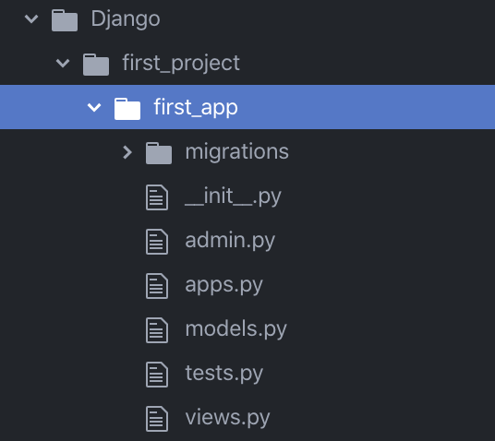

Default files explanation

1. **init__.py**
   * As same as before, this is a blank Python script that due to its special name let’s Python know that this directory (first_app) can be treated as a package
2. **admin.py**
   * You can register your models here which Django will then use them with Django’s admin interface.
   * This is a builtin and powerful tool of Django
3. **apps.py**
   * Here you can place application specific configurations
4. **models.py**
   * Here you store the application’s data models
   * Here we specify the entities and relationship between the data
5. **tests.py**
   * Here you can store test functions to test your code
6. **views.py**
   * This is where you have functions that handle requests and return responses

**Migrations Folder**

* + This directory stores database specific information as it relates to the models

The views.py and models.py are two important files we will be using for any given application. Along with Template, this is called Model View Template design pattern.

Before we get started, we need to tell Django that “first_app” actually exists.

Go to settings.py file to specify it there and then we can create a VIEW and map it to URL to complete the process.

## Adding an app is settings.py file

Scroll down and add the app name under INSTALLED_APPS tag as shown in the image below

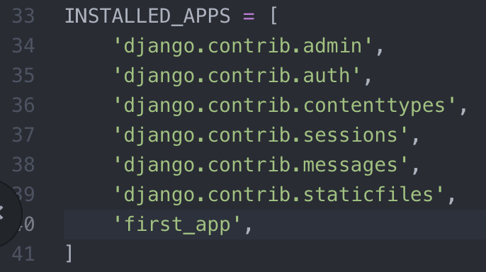

All above mentioned apps are Django’s default apps which are added automatically when the project was created.

Run server again to make sure everything is working fine. If we don’t get the error, it means everything is fine.

>> python manage.py runserver

## Creating a VIEW of the app:

Now lets open the views.py file and add the following lines of code as shown below:

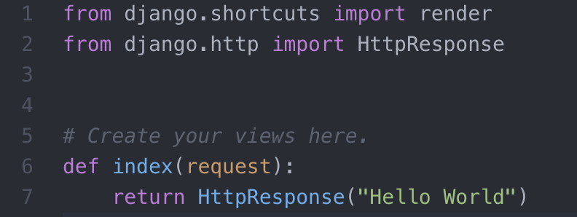

1. Default import directory
2. We have to use HttpResponse Object from Django.http module

NOTE: each view in this application will exist within views.py file as its own separate function. So here “index” is one such view.

1. Definition of a view named “index”

* Each view takes at least one argument
* For HttpResponse object, we call this argument a “request”.   
  *Any name can be given to this argument.*
* Each view must return the HttpResponse object
* In this example, we are simply returning “Hello World”

Now to actually see this *view* on our running server, we need to map this *view* to URLs.py file.

## Mapping the view in urls.py

Go to urls.py file (the file located inside the Django project folder) and add the following code:

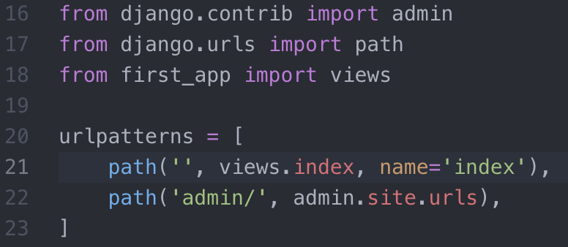

16 and 17. Default import files added

18. here you import your own **app** views file.

21. First a regex string ‘’, filename.functionname, name of the view

*Note: In earlier versions of Django, the url was used to be mapped with a keyword “url” instead of “path” as shown in figure above.*

*Note: If the view would be defined as a class rather than a function, then it would have written as filename.classname().as_view(). Example: if the class name is hello, then views.hello().as_view().*

Lets run the server again to test if it works fine.

*Challenge Note: While attempting a challenge, I forgot to include the app name “AppTwo” in settings.py file, but it still worked. Don’t know the reason yet.*

# Django Level 1 - Part 6 – URL Mappings

As we continue on through the course we are going to be dealing with mapping URLs quite a bit. There are several ways of doing this.

* We previously showed a very direct mapping from the views.py to the urls.py
* Now we want to show the ability of using the **include()** function from **django.conf.urls**
* The **include()** function allows us to look for a match with regular expressions and link back to our application’s own **urls.py** file.

NOTE: The default urls.py file which exist is created when we create a Django project. That is the file is inside the project folder. In order to create the application’s own urls.py file, we will have to manually add in this **urls.py** file inside the application’s directory.

First, we would add the following to the project’s urls.py file

* from django.conf.urls import include
* urlpatterns = [ ... re_path(r’^first_app/’,include(‘first_app.urls’)), ...]

This would allow us to look for any url that has the pattern:

* [www.domainname.com/first_app/…](http://www.domainname.com/first_app/…)

If we match that pattern, the include() function basically tells Django to go look at the urls.py file inside of first_app folder. This might seem like a lot of work for a simple mapping, but later on we will want to try to keep our project’s urls.py clean and modular. So, we set the reference to the app, instead of listing them all in the main urls.py.

Now the main (project’s) urls.py file would look like the image shown below.

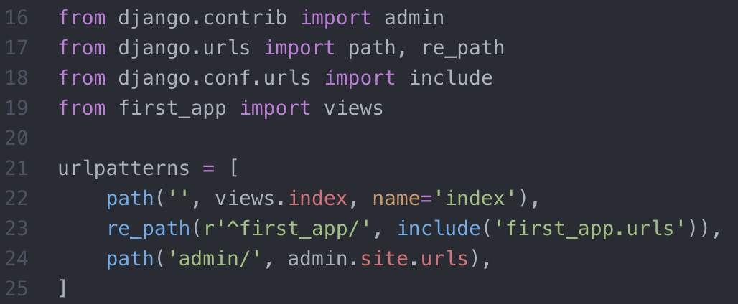

NOTE: in order to define regular expressions in URL patterns, we need to use “re_path” as shown in line 23 in above figure.

Now, lets add the urls.py file inside the “application’s” directory.

# Django Level 1 - Part 7 – Templates

Templates are a key part to understanding how Django really works and interacts with your website. Later on, we will learn about how to connect templates with models so you can display data created dynamically.

* **The template will contain the static parts of an html page (parts that are always the same)**

**Template tags**, have their own special syntax which allows you to inject dynamic content that your Django App’s views will produce, effecting the final HTML.

To get started with templates you first need to create a templates directory and then a subdirectory for each specific app’s templates. It goes inside of your top-level directory:

* first_project/templates/first_app

The next step is to let Django know of the templates by editing the DIR key inside of the TEMPLATES dictionary in the settings.py file.

WARNING: There is an issue we have to deal with before we do this!

The DIR key will require a “hard-coded” path, then how do we make our Django Project be easily transferrable from one computer to another? We can’t hard-code the file path with our own user name, or in case of someone using the different operating system.

SOLUTION: We can use Python’s os module to dynamically generate the correct file path strings, regardless of computer!

Import os and try out the following:

* print(__file__)
* print(os.path.dirname(__file__)

It will return the path of the file. Therefore, we can use this “os” module to feed the file path to the DIR key inside of the TEMPLATES dictionary.

**Django Template Variables:**

These Django Template Variables (DTV) allow us to inject content into the HTML directly from Django. We insert DTV in HTML files.

This is now starting to reveal the power of why a Web Framework is important to use. Django will be able to inject content into the HTML, which means we can later on use Python code to inject content from a database. In order to achieve this, we will use the **render()** function and place it into our original index() function inside of our views.py file.

Go to settings.py and add the following line 17 to print the current file path

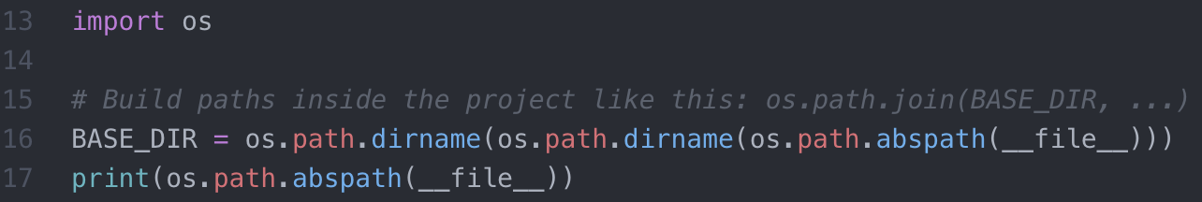



Also see below the “BASE_DIR” variable contains the path of the base directory of Django Project.

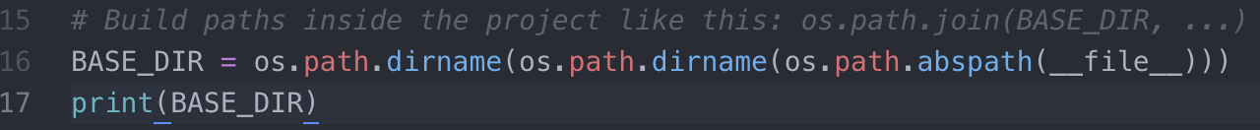

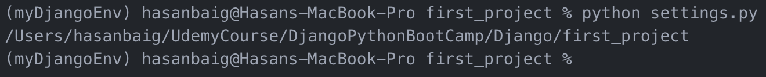

**Note:** We have used “os.path.dirname()” twice to get the path of the base directory which is already assumed to be two level up of the current settings.py file. That is, it is clearly understood that the settings.py file is placed under ~/first_project/first_project/ directory.

**Adding Templates Directory**

Now following the same previous procedure, we can add the templates directory (which can be used on any machine).

If we try to join the paths with “+” like this:

BASE_DIR+“\templates” it may not work, because first “\t” is a tab-space character. Second, different OS may have different path formats, for example backslashes “\” are used in Windows, whereas forward slashes (/) are used in Mac. Therefore, we can’t follow this procedure of constructing the path of templates directory. What we can do is to use the following command to join the BASE_DIR path and templates directory and store the path in a variable named TEMPLATES_DIR

>>TEMPLATES_DIR = os.path.join(BASE_DIR, “templates”)





Now we have to add this variable into TEMPLATES dictionary object in the settings.py file as value of “DIR” key, as shown below:

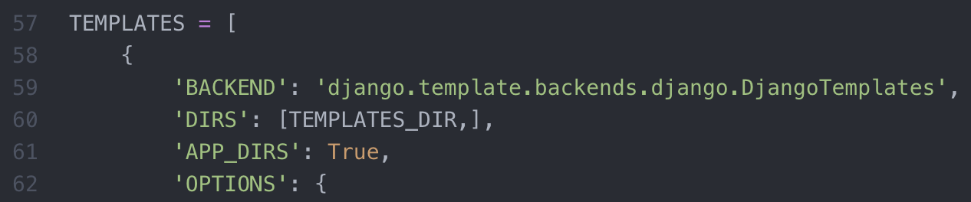

Now lets move to adding the actual template file named index.html under templates/first_app directory and add a templates tag “message” (DTV) in it, as shown below:

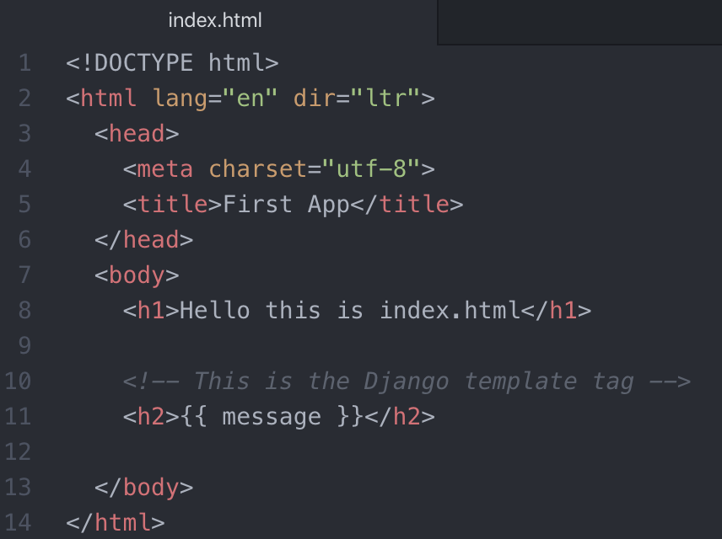

Now we have to hook up this template variable ( message ) to our application (first_application).

Go to views.py. Make sure that render function is imported (see image below) and edit the index(request) definition as shown below:

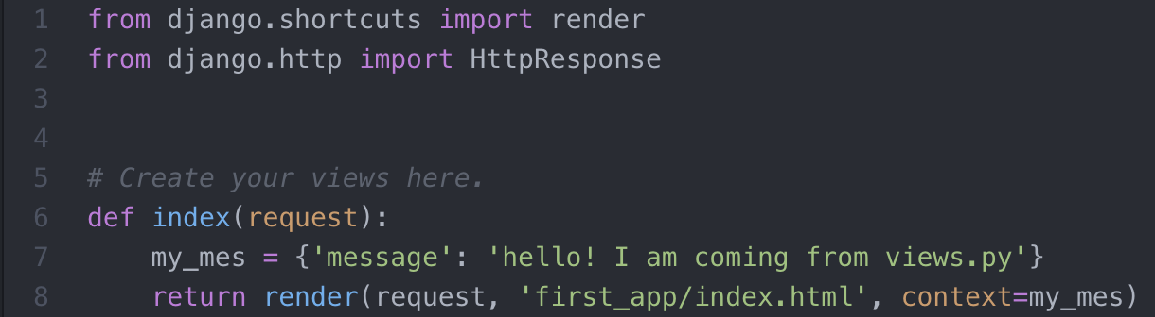

WARNING: The template tag is the name of dictionary keyword which we have defined in the views.py file at line 7.

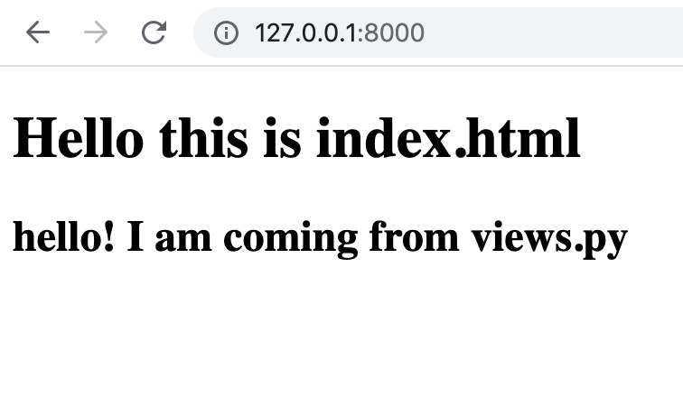

The Django template tag (line 11 in index.html file) can also be enclosed inside html tags like <h2> as shown in line 11.

# Django Level 1 - Part 10 – Static Files

So far we’ve used templates to insert simple text. But we don’t always just want text, what about other types of media, for example, returning a User’s Photo? Lets discuss this.

* To do this, we will create a new directory inside of the project called **static** (just like we did for templates)
* Then we will add this directory path to the project’s **settings.py** file, as shown below:

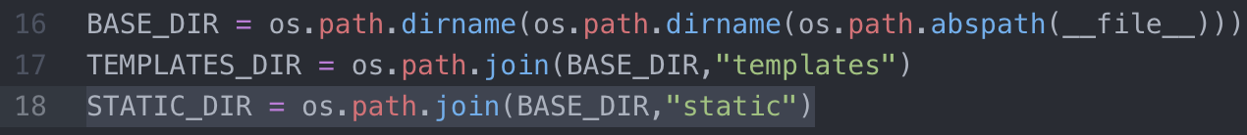

* We will also add a STATIC_URL variable

*Scroll all the way down to the settings.py file, where you will notice (line 122 in image below) that the pre-built STATIC_URL variable leading to the path for static files. We will define a list of Static files in case that we may have multiple applications and each application has its own separate static directory. In this case, we have already declared the path of our static files (line 18 above), which we will use as the first member of the list shown below:*

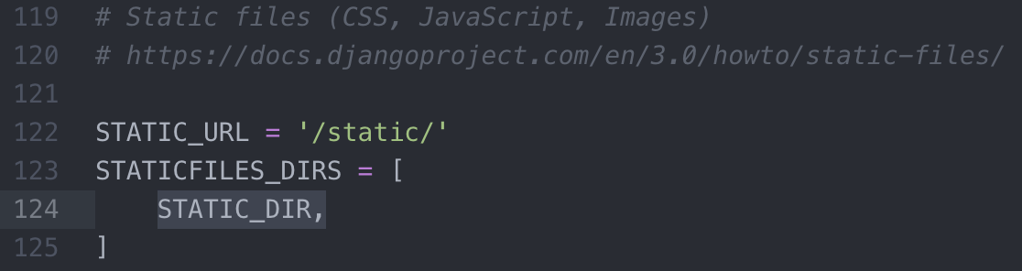

*Note: The link given at line 120 can be accessed to get more information about how to include static files in Django project.*

*NOTE: Make sure STATICFILES_DIRS variable does not already exist.*

Once we’ve done that, we need a place to store our static image files. We **create a directory inside of static called images**. Then, place a favorite .jpg file inside the images directory (or just download one).

* To test that this all worked you can go to:
  + 127.0.0.1:8000/static/images/Ramdan.jpg
* That will confirm that the paths are set up and connected properly.

Now, we will use template tagging to induce this image in an HTML file.

Now what we really want to do is set up a template tag for this. To do this inside an html file, we add in a few specific tags, at the top:

* + {% load static %}

*WARNING: it is* ***{% load staticfiles %}*** *in earlier version of Django.*

NOTE: The above line should be inserted after the “DOCTYPE” HTML tag, as shown below:

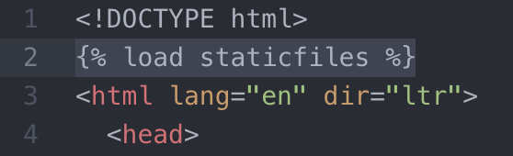

Then we want to insert the image with an HTML <img src= > style tag using:

* + <img src={%static “images/Ramdan.jpg” %} />

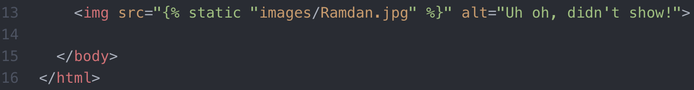

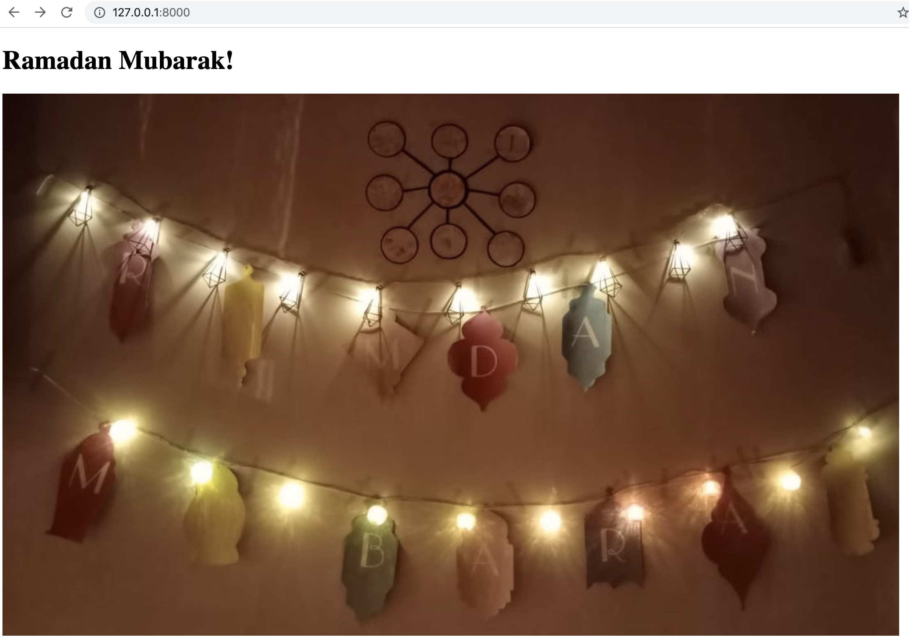

Note: **alt = “”** is used to display the message when something goes wrong and image was not able to be loaded. Lets try out by simply changing the name of jpg file and see how the page responds.

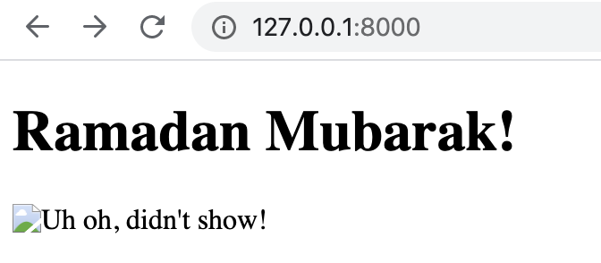

* Notice how this template tag is a little different in that it uses {% %} instead of {{ }}

We will discuss and show these differences more clearly in future lectures, but for now consider

* {{ }} 🡺 as being used for simple text injection, and
* {% %} 🡺 used for more complex injections and logic

Apart from images, we can also add some other type of static files, like css/javascript files. For example,

* Create a **css** folder under **static** folder and create a new file called **mystyle.css** in there
* Change the heading <h1> color as shown below

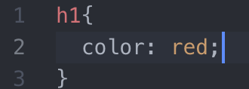

* Now add the css file path in the html file i.e. in index.html file. This time we will not add the hard-coded css file path, rather we will use the template tags to include the css file as shown in the image below:

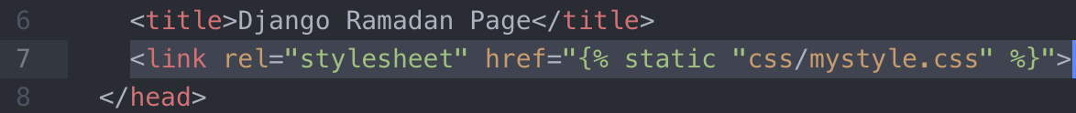

* Refresh the page and you will notice the heading color is changed to red.

SUMMARY: Lots of Django stuff is called MTV (Model Template VIEWS). We have already dealt with Templates and Views a bit, and in next level, we will talk about Django Models.

**\*\*\*\*\*\*\*\*\*\*\*\*\*\*\*\*\*\*\*\*\*\*\*\*\*\*\*\*\*\* Django Level 1 Ends Here \*\*\*\*\*\*\*\*\*\*\*\*\*\*\*\*\*\*\*\*\*\*\*\*\*\*\*\*\*\*\***

**\*\*\*\*\*\*\*\*\*\*\*\*\*\*\*\*\*\*\*\*\*\*\*\*\*\*\*\*\*\*\*\*\*\* Django Level 2 \*\*\*\*\*\*\*\*\*\*\*\*\*\*\*\*\*\*\*\*\*\*\*\*\*\*\*\*\*\*\*\*\*\*\***

**\*\*\*\*\*\*\*\*\*\*\*\*\*\*\*\*\*\*\*\*\*\*\*\*\*\*\*\*\*\*\*\*\*\*\*\*\*\*\*\*\*\*\*\*\*\*\*\*\*\*\*\*\*\*\*\*\*\*\*\*\*\*\*\*\*\*\*\*\*\*\*\*\*\*\*\*\*\*\*\*\*\*\*\*\*\*\*\***

# Django Level 2 - Intro

So far, we have covered the following aspects of Django project

* + Setting up Projects and Applications
  + Creating Views and Mapping URLs
  + Using simple Templates and tags
  + Serving static media files

A quick overview is given in Django – level 2 – Introduction video:

<https://www.udemy.com/course/python-and-django-full-stack-web-developer-bootcamp/learn/lecture/6615602#content>

In this Level, we will begin to discuss Models and Databases and how to use them with Django. Then we will also discuss how to use the admin interface.

# Django Models Overview

An essential part of any website is the ability to accept information from a user and input it into a database and later on retrieve information from a database and use it to generate content for the user.

**Models** are used to incorporate a database into a Django Project.

* Django comes equipped with SQLite.
* SQLite will work for our simple examples, but Django can connect to a variety of SQL engine backends!
* In the **settings.py** file you can edit the **ENGINE** parameter used for DATABASES

To create an actual model, we use a class structure inside of the relevant applications **models.py** file. This class object will be a subclass of Django’s built-in class:

* **django.db.models.Model**
* Then each attribute of the class represents a field, *which is just like a column name with constraints in SQL*

## SQL Database Overview

SQL operates like a giant table, with each column representing a field, and each row representing an entry.



* Each column has a type of field, such as a CharField, IntegerField, DateField, etc.
* Each field can also have constraints. For example, a CharField should have a max_length constraint, indicating the maximum number of characters allowed

The last thing to note is table (or models) relationships. Often models will reference each other. For this referencing to work we use the concepts of **Foreign Keys** and **Primary Keys**.

* Imagine we now have two models.
* One to store website information, another to store date information



Imagine that we have two models (or databases) as shown above. WebsiteId column is common to both the databases. So, we could say that the **WebsiteId** column is a primary key in the left table and **foreign key** in the right table.

Primary Key: A primary key is a unique identifier for each row in a table.

Foreign Key: A foreign key just denotes that the column coincides with a primary key of another table.

Later on we will move on to discuss One-to-one or Many-to-many relationships.

## Example of models class

Lets see how does a model class looks like.





As already mentioned before that the models are inherited from the builtin models.Model class, here we have three different models “Topic”, “Webpage” and .

* We define the top_name to be a character field with a max_length constraint and a unique = true set for each topic
* Then we have another model name Webpage, where we have three different fields in it
  + category 🡪 inherited as a ForeignKey from the first database (Topic model)
  + name
  + url
* Then we have another model Webpage having the following three fields
  + topic 🡪 inherited as a ForeignKey from the first model (Topic)

NOTE: In Django 3.0, ForeignKey requires another positional argument “on_delete” which is not declared here. We will specify it later in our codes.

* + name
  + url
  + in this model, we also have a return method to return the “name” field. So if we say print(Webpage), it will grab the name.

After we’ve set up the models we can **migrate** the database. This basically let’s Django do the heavy lifting of creating SQL databases that correspond to the models we created. This is the coolest thing about Django and Python that you just define a class and the entire database is generated behind the scene.

Django can do this entire process with a simple command:

>> python manage.py migrate

Then register the changes to your app, shown here with some generic “app1”:

>> python manage.py makemigrations app1

Then migrate the database one more time:

>> python manage.py migrate

We can then later use the shell from the manage.py file to play around with the models.

**Using the models with Admin Interface**

In order to use the more convenient Admin interface with the models however, we need to register them to our application’s admin.py file.

We can do this with the following code:

>> from django.contrib import admin

>> from app.models import Model1, Model2

>> admin.site.register(Model1)

>> admin.site.register(Model2)

Then with the models and database created, we can use Django’s fantastic Admin interface to interact with the database. This Admin interface is one of the key features of Django.

Now, in order to fully use the database and the Admin, we will need to create a “superuser”. We can do this with the following:

>> python manage.py createsuperuser

We will be asked to provide a name, email, and password

Once the models are set up, it’s always good idea to populate them with some test data

* We will use a library to help with this called Faker and create a script to do this.

## Creating Models

Working on first_app models.py file.

NOTE: models.py file belongs to each individual app.

We will use OOP concepts to create models.

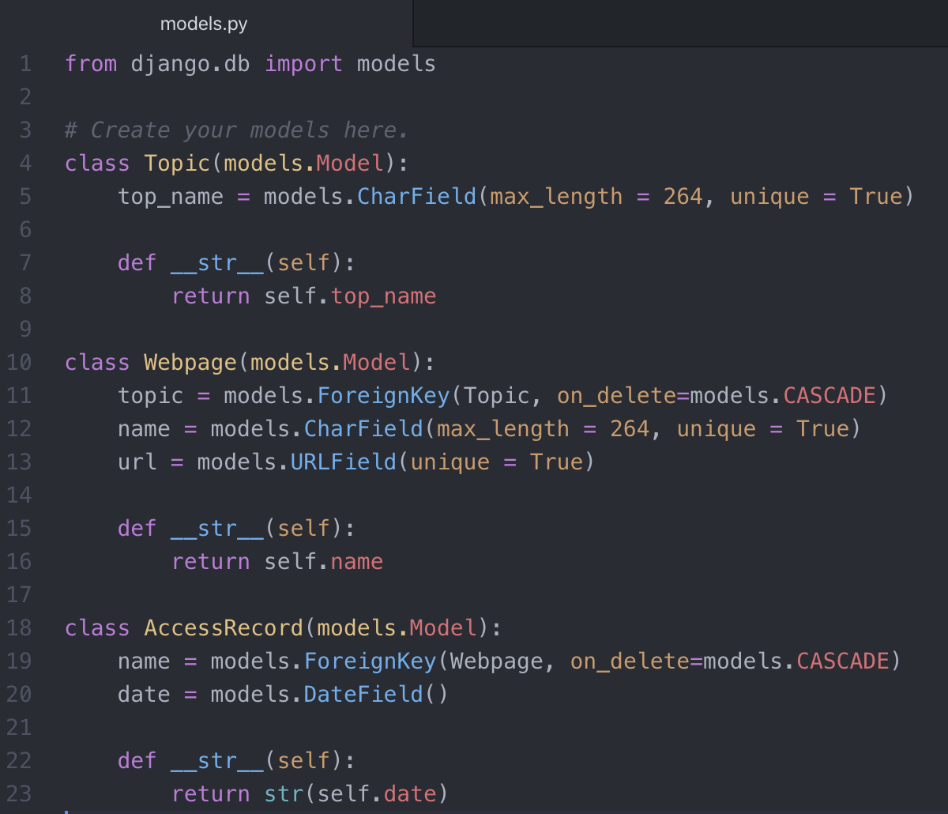

* def __str__ : to print out the instance attribute of your model.
* on_delete: this argument is used to emulate the behavior of the SQL constraint in case if the object referenced by a ForeignKey is deleted.

Now that our models are written, we now need to generate the SQL database using the commands we have discussed before:

The first thing is to migrate the models, as shown below.

1. >> python manage.py migrate

If migration is successful, you will see the screen with “OK” in front of every line below:

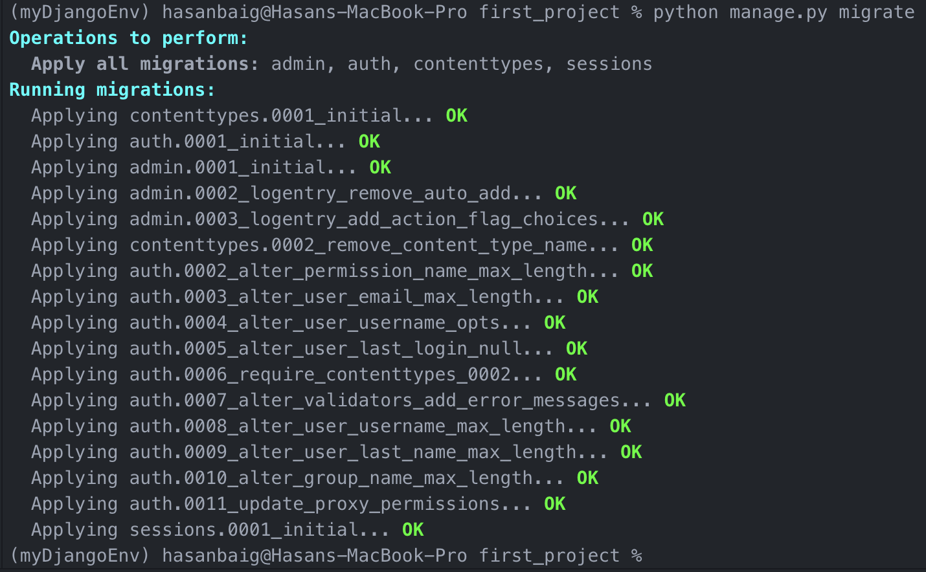

If we try to run the abovementioned command again, we will be notified that the changes have not been reflected in a migration. As indicated, we need to run makgemigrations command first.

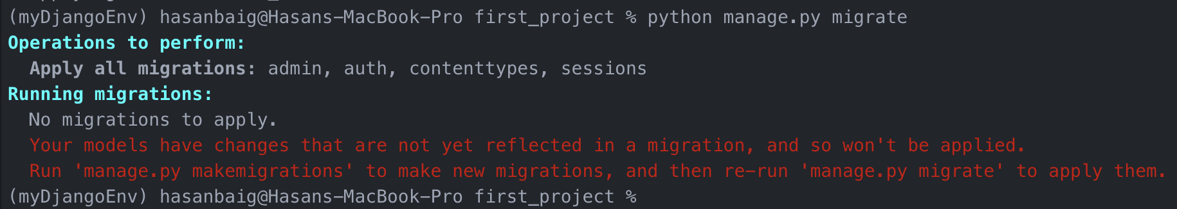

1. >> python manage.py makemigrations first_app

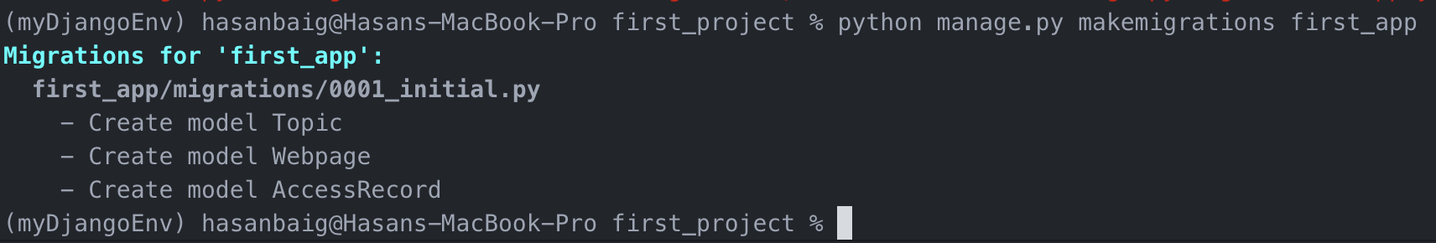

Now run the migrate command again one more time.

1. >> python manage.py migrate

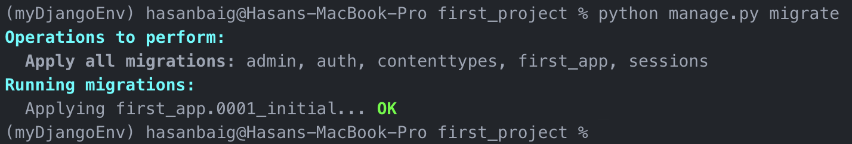

Now when we run the same command again, it should say that “No migrations to apply”.

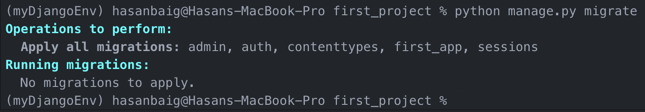

Now our models should be ready to be connected to SQL database which Django has just created for us.

----------------------------- ----------------------------- ----------------------------- -----------------------------

**Database Verification using Python Shell**

How to make sure that the database is generated and how can we interact with it. For this, we will use Python shell commands to verify that the database is created. Open a python shell using the following command

>> python manage.py shell

Once the shell is active, you will see a command interface like this:

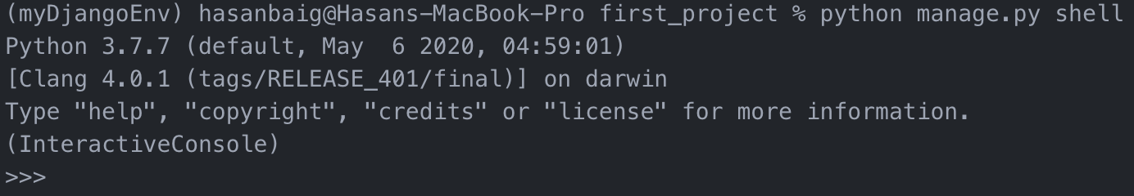

1. First import the model

>> from first_app.models import Topic

*If you get the error, it might be because you forgot to* ***migrate*** *the model.*

1. We can then print the objects in the Topic model.

>> print(Topic.objects.all())

--> <QuerySet []>

*We did not get anything for the first time because the database is currently empty. Lets create an entry in it.*

1. Add a topic name “Social Network” and save it in the database

>> t = Topic(top_name = "Social Network")

>> t.save()

*Now run the previous command of printing the objects again to see the topic Social Network is listed as a topic as shown below:*

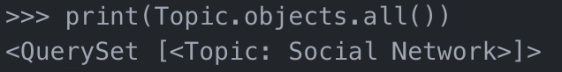

1. Quit and come out of the shell

>> quit()

We created models and created a database behind them. Then we used shell commands to add something in it. Now we will not be using shell every time to work with database like adding or retrieving the data from the database. We will rather use an “Admin Interface”, which is a very powerful feature of Django, with very little work on the developers’ side.

----------------------------- ----------------------------- ----------------------------- -----------------------------

To have the admin interface with the models, we need to register the models with the application’s admin.py file.

1. Go to first_app/admin.py file. Import the application’s model and register them as shown below:

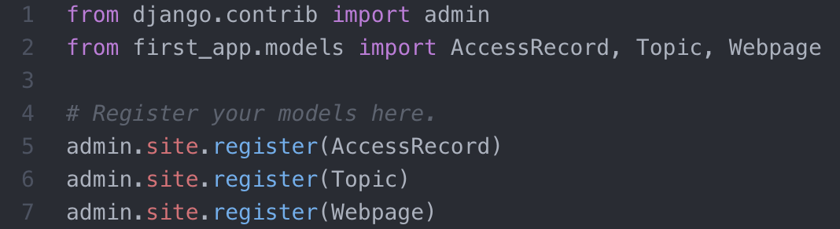

To fully use the admin interface, we need to create a super user (i.e. the admin user) so not everyone come and mess around with the database.

1. Create a superuser as shown in the image below:

>> python manage.py createsuperuser

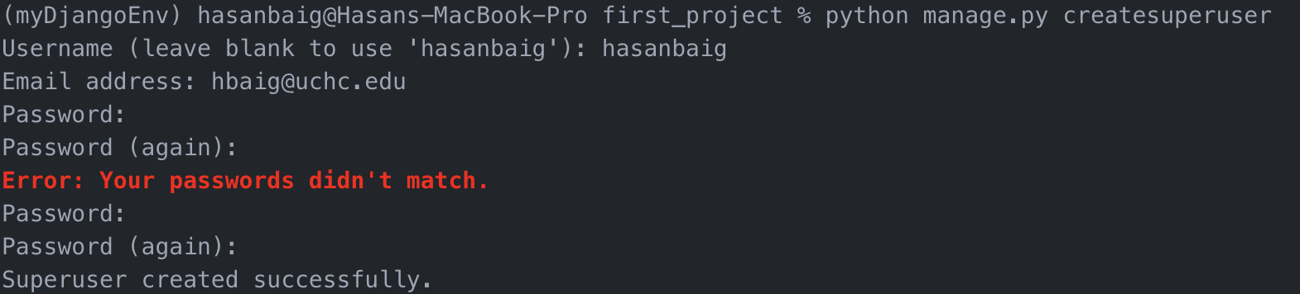

At least superuser has to be created like this. Additional superusers can be added using the admin interface.

1. Now run the server to test the admin interface.

>> python manage.py runserver

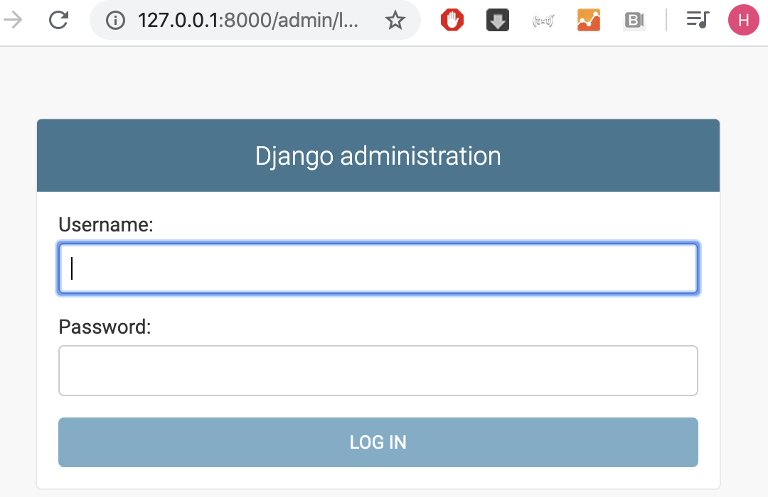

Now go to URL page and type ~/admin where you will see an admin login interface as shown in the image above. Once you logged on with the credentials you set up in step 5 above, you can explore your database; see the existing entries; add more entries; add more users, etc.

Now coming up next, we will talk more about models and learn how to use “Faker” library to populate databases.

## Populating Models using Population Scripts

It is usually a good idea to create a script that will populate your models with some “dummy” data. Let’s show you how to use the Faker library to create this script.

First of all, we need to download the “Faker” library using pip. Type in the following command in command window as shown below:

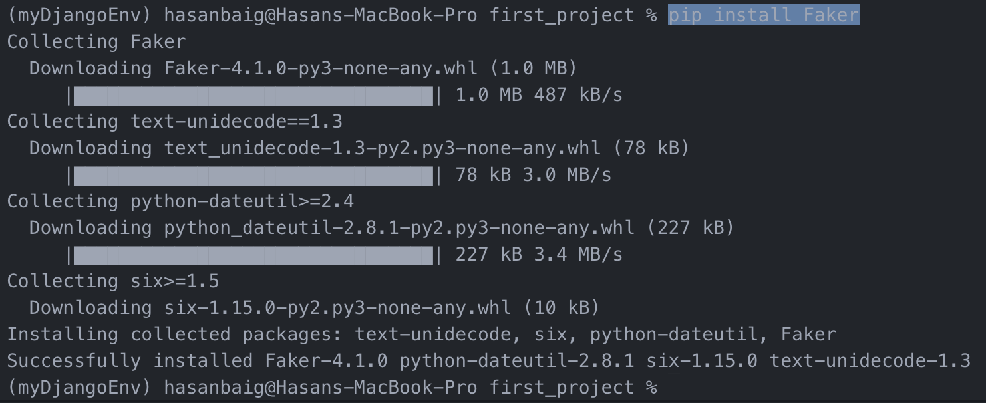

Now look at the Faker documentation at faker.readthedocs.io

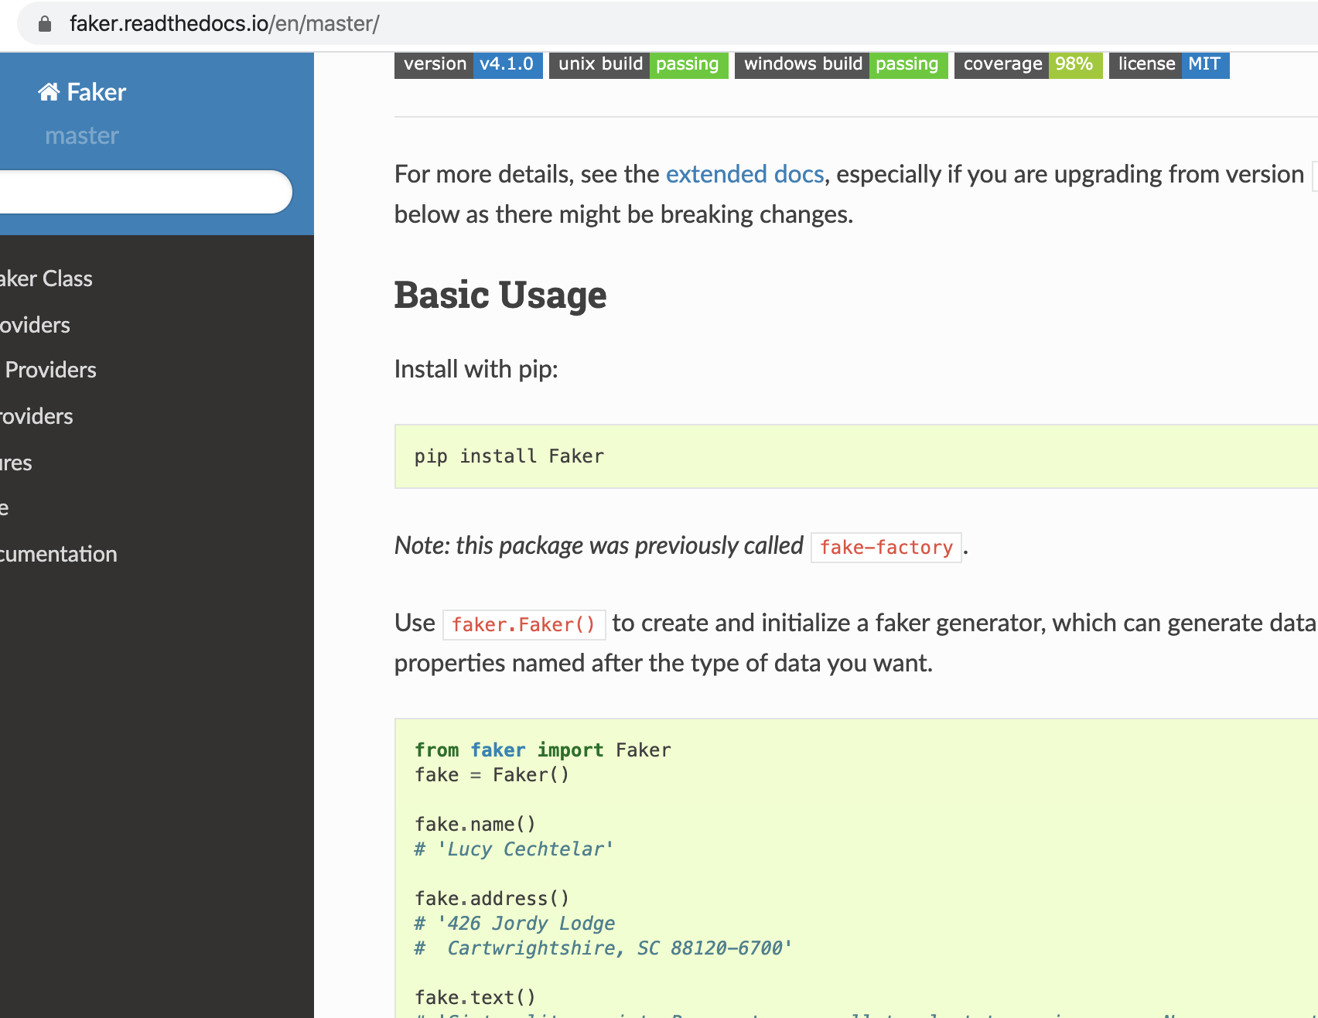

Create a new file to save the population script in the **first_project** directory with a name **populate_first_app.py**. Now write the following code. For explanation of this file, go to <https://www.udemy.com/course/python-and-django-full-stack-web-developer-bootcamp/learn/lecture/6616114#overview>

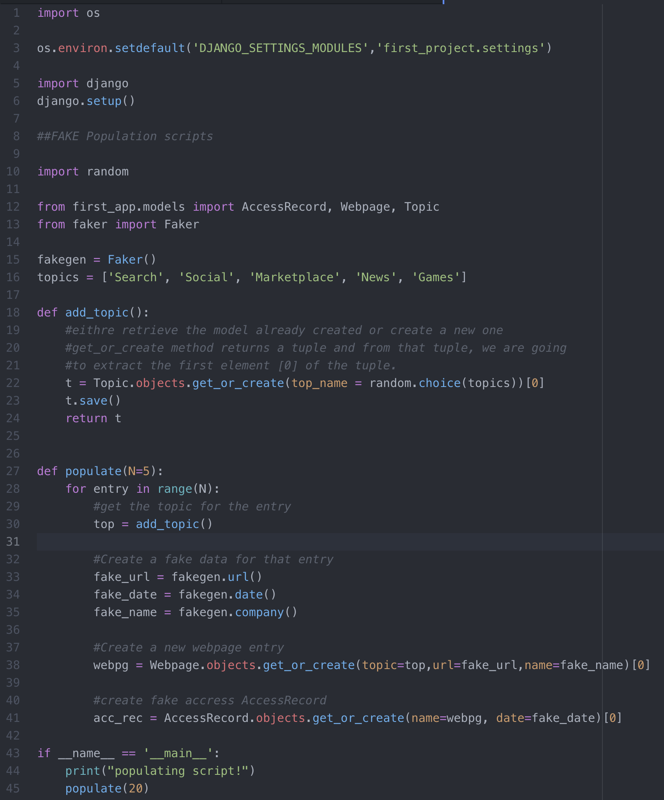

Once the file is ready, run the file

>> python populate_first_app.py

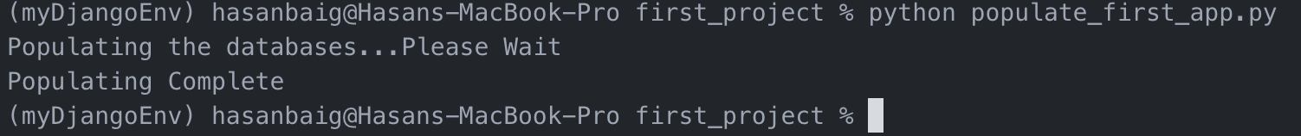

Now run the server (python manage.py runserver); go to the admin panel, and check the randomly generated data there.

## Models-Templates-Views Paradigm

Django operates on what is known as Models-Templates-Views. This is also called “MTV” and encompasses the idea of how to connect everything we’ve talked about so far: models, templates, and views.

There are a few basics steps to achieving the goal of serving dynamic content to a user based off the connection of the models, views, and templates. The steps are:

1. In the **views.py** file we import any models that we will need to use.
2. Use the view to query the **model** for data that we will need.
3. Pass results from the model to the **template**.
4. Edit the template so that it is ready to accept and display the data from the model.
5. Map a URL to the view.

We can practice this methodology by changing what we display on the front index page. To begin our understanding of this process we will start by generating a table.

* The table will display all the webpages and access records from the AccessRecord database we created and populated.
* We will use template tagging to connect the model to the html page.

Now lets work on it.

Go to views.py file inside first_app folder. There we have a simple and only one view defined, named “index”. We can now connect this view to database by importing models Topic, Webpage, AccessRecord

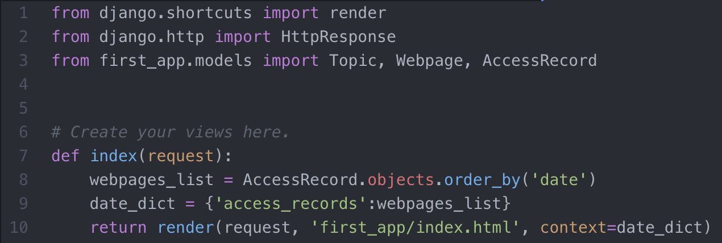

* Line 3: imports the models
* Line 8: Fetch the access record data objects and arrange them in order by date using the method “order_by(‘date’)”. Store these objects in webpages_list variable
* Line 9: dictionary to hold the access records and pass it to index.html page using “render” function and display it there using template tag.

Now go to index.html page and define the html from scratch as shown below:

* Line 2: good practice to include this tag at the top in case of using static files later. We are using css file in this example.
* Line 14: a div tag to enclose the access record data.
* Line 15: Checks if “access_records” key exists in views.py then
* Line 16-33: Table initialized
  + Lines 17-20: Table headings – Site Name, Date Accessed
  + Line 21-26: Looping through the AccessRecord database to display the name and date of each entry present in AccessRecord database.
    - Line 21: adding a for loop to access all the data in AccessRecords models. rec is the current loop item in access_records list. access_records is the dictionary key defined in views.py file.
    - Line 22: creating table row tag
    - Line 23-24: creating table cell tags
  + Line 26: End for loop
* Line 29: Else branch
* Line 31: end of if structure

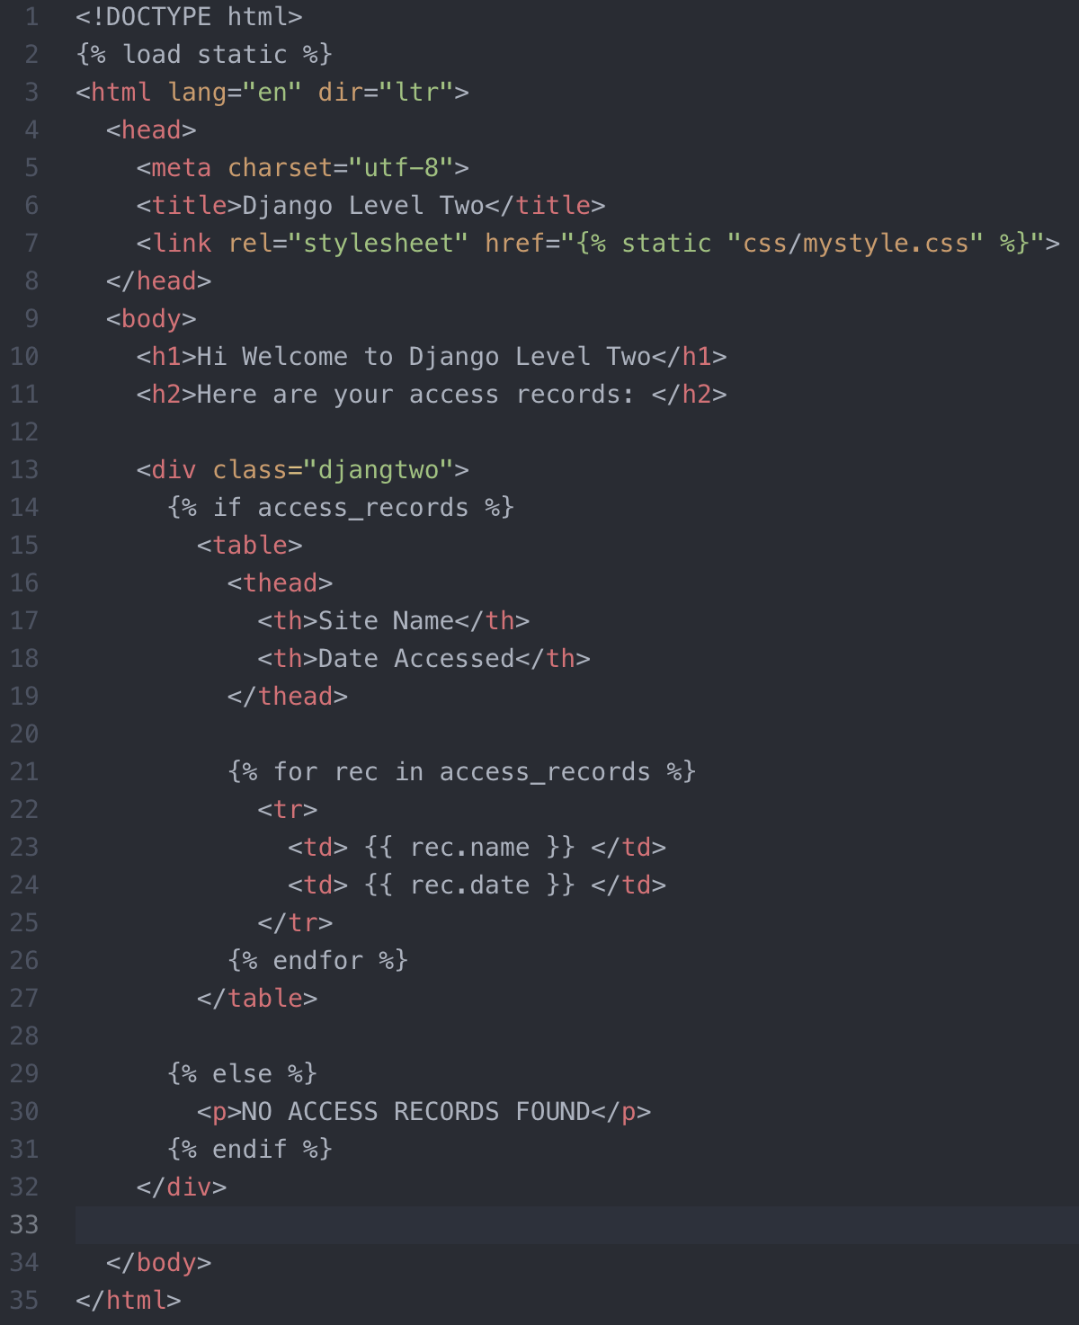

Now run the server again to see if that works on the webpage.

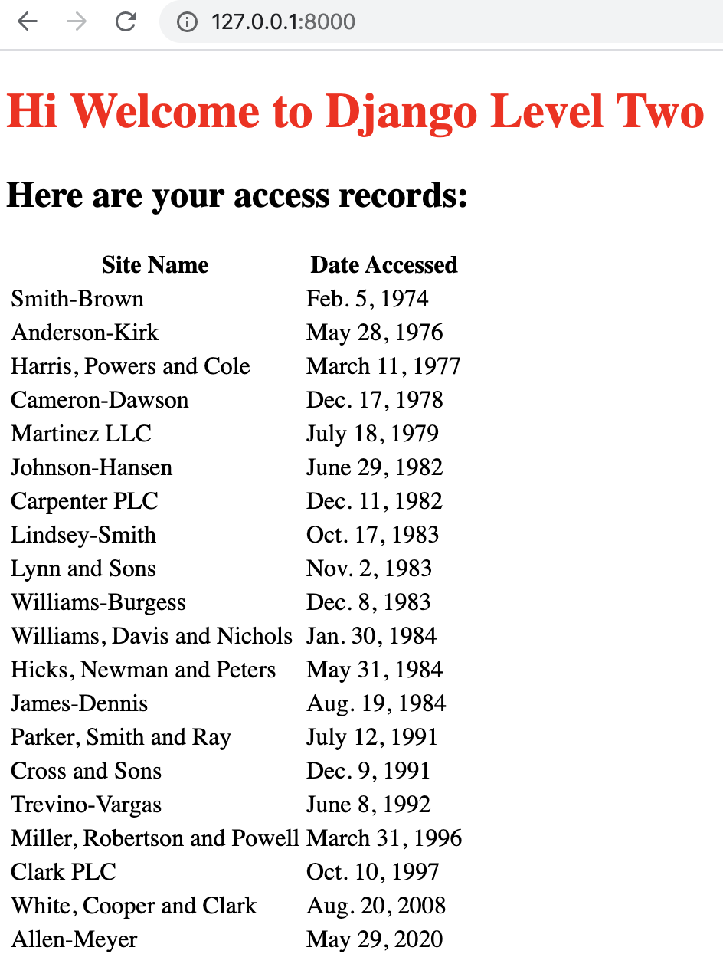

Now, lets give a little bit of styling to the table using css.

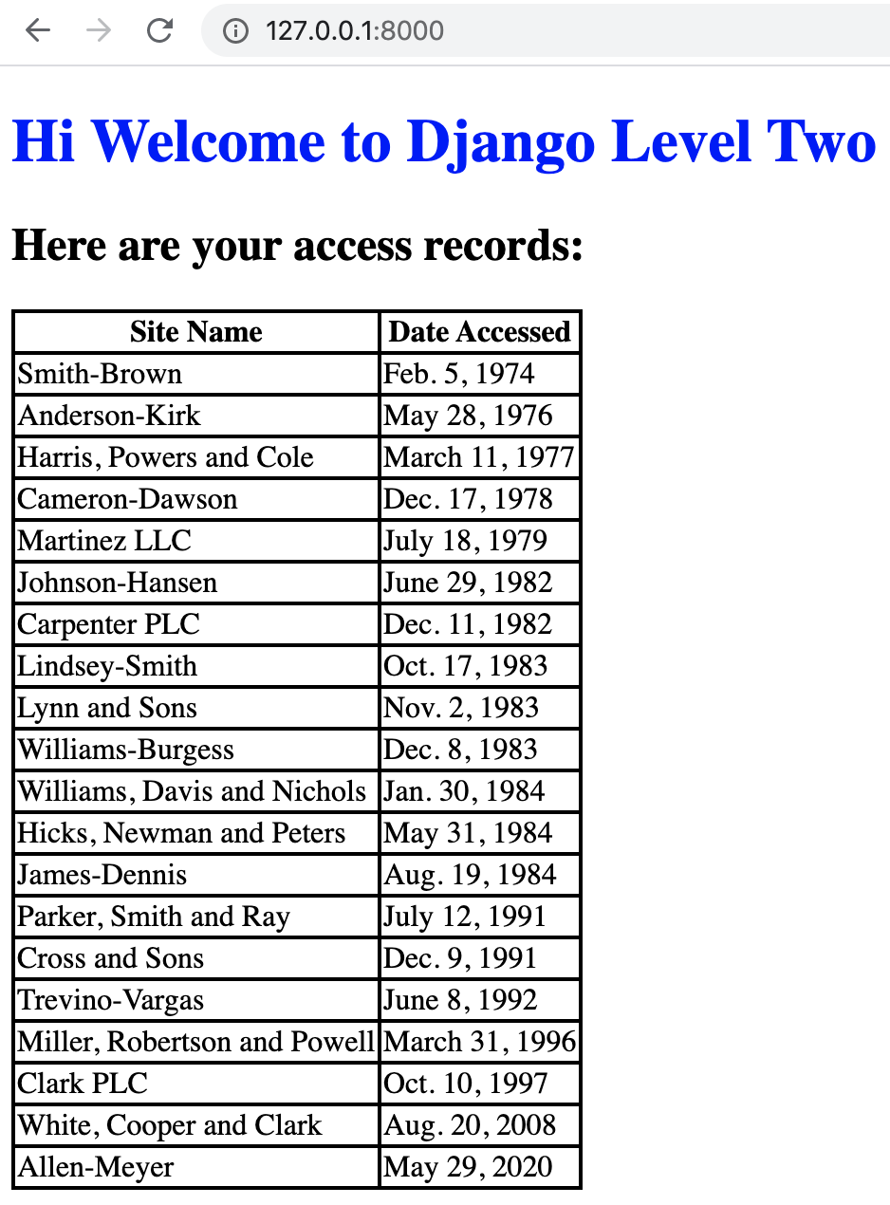

**\*\*\*\*\*\*\*\*\*\*\*\*\*\*\*\*\*\*\*\*\*\*\*\*\*\*\*\*\*\* Django Level 2 Ends Here \*\*\*\*\*\*\*\*\*\*\*\*\*\*\*\*\*\*\*\*\*\*\*\*\*\*\*\*\*\*\***

**\*\*\*\*\*\*\*\*\*\*\*\*\*\*\*\*\*\*\*\*\*\*\*\*\*\*\*\*\*\*\*\*\*\* Django Level 3 \*\*\*\*\*\*\*\*\*\*\*\*\*\*\*\*\*\*\*\*\*\*\*\*\*\*\*\*\*\*\*\*\*\*\***

**\*\*\*\*\*\*\*\*\*\*\*\*\*\*\*\*\*\*\*\*\*\*\*\*\*\*\*\*\*\*\*\*\*\*\*\*\*\*\*\*\*\*\*\*\*\*\*\*\*\*\*\*\*\*\*\*\*\*\*\*\*\*\*\*\*\*\*\*\*\*\*\*\*\*\*\*\*\*\*\*\*\*\*\*\*\*\*\***

# Django Level 3 – Intro

After learning with the possibilities of the MTV workflow of Django, we are still missing a big piece to creating a full website - user input.

In this section we will be covering how to use Django Forms to accept User Input and connect it to the database and retrieve it later on.

## Django – Basic Forms

In this section we will conceptually walk through the process of creating a form with Django. But the question arises here is that we’ve already covered Forms when discussing HTML, so why bother with Django Forms? What extra features do they bring? There are clearly some advantages of using Django forms, out of which the distinct ones are given below:

* Quickly generate HTML form widgets (input types, email, phone etc). It allows you to generate such inputs quickly with template tagging
* Validate data and process it into a Python data structure
* Create form versions of our Models, quickly update models from Forms

## Theoretical STEPS to create Django Forms

1. The first thing we need to do is to create a forms.py file inside the application.
2. After that we call Django’s built in forms classes (looks very similar to creating models). For example, inside of forms.py:
   * *from django import forms*
   * *class FormName(forms.Form):*
   * *name = forms.CharField()*
   * *email = forms.EmailField()*
   * *text = forms.CharField(widget=forms.Textarea)*

Note how similar this feels to creating a model. Now that we have the form created inside the application’s forms.py file, we need to show it by using a view.

1. Inside our views.py file we need to import the forms (two ways to do this)
   * from . import forms
   * from forms import FormName

NOTE: The **.** just indicates to import from the same directory as the current .py file

1. Once the form is imported, we can create a view for it in the views.py file as same as we created a model. For example:

def form_name_view(request):

form = forms.FormName()

return render(request,’form_name.html’, {‘form’:form})

1. Then we just add the view to the app’s urls, either directly or with include(). Directly:

from basicapp import views

urlpatterns = [

url(r’formpage/’,views.form_name_view,

name = ‘form_name’),

1. We can then create the templates folder along with the html file that will hold the template tagging for the form.
2. Update the settings.py file to reflect the TEMPLATE_DIR variable.
3. Views should reflect subdirectories inside templates.

So now everything is setup for us to go into the form_name.html file inside templates/basicapp and add in the actual template tagging that will create the Django Form.

There are several ways we can “inject” the form using template tagging. We can just pass in the key from the context dictionary:

* + {{ form }}

Once you’ve put in the {{forms}} tag you should be able to see a very basic (and ugly) form on the page. However, there is no actual HTML <form> tag there.

----------------------------- ----------------------------- ----------------------------- -----------------------------

**HTTP, GET and POST:**

**HTTP:**

HTTP stands for Hypertext Transfer Protocol and is designed to enable communication between a client and a server.

* The client submits a request, the server then responds
* The most commonly used methods for this request/response protocol are **GET** and **POST**.

**GET:**

* requests data from a resource

**POST:**

* submits data to be processed to a resource

More can be explored at [www.w3schools.com](http://www.w3schools.com).

----------------------------- ----------------------------- ----------------------------- -----------------------------

Let’s look at what a more completed form html page would look like.

On form.html page, we may have something like this

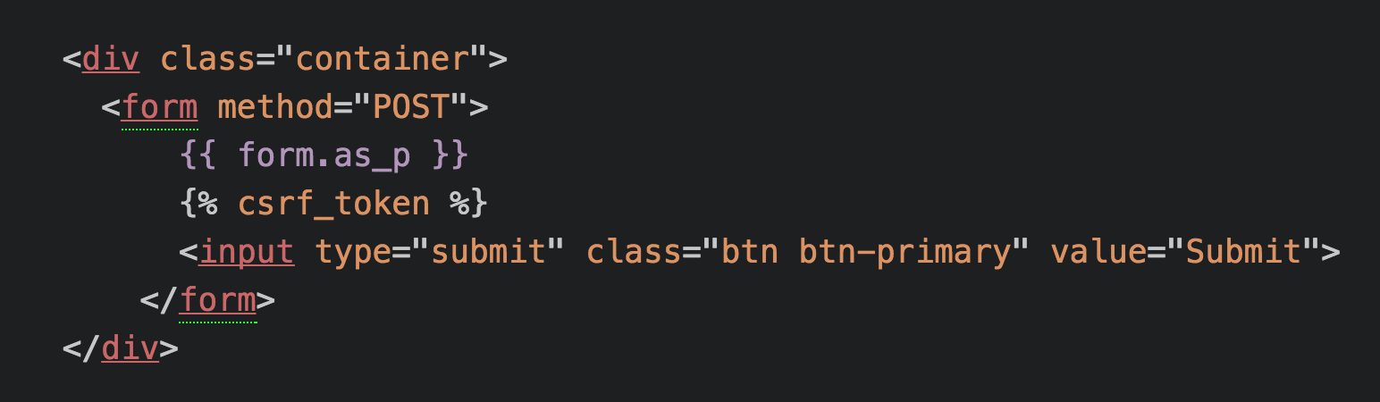

* Some added Bootstrap class styling calls i.e. class=”container”
* Also calling form.as_p which uses <p> (paragraph) which allows you to have a nicer layout from top to bottom instead of left-to-right.

NOTE: Check Django documentation for other methods, for example request a form as a table.

* Also added {% csrf_token %}. This is a Cross-Site Request Forgery (CSRF) token, which secures the HTTP POST action that is initiated on the subsequent submission of a form. When we click submit, this token help protect from getting the false data or externally sending the data to somewhere else.
  + The Django framework requires the CSRF token to be present. If it is not there, your form may not work.
  + It works by using a “hidden input” which is a random code and checking that it matches the user’s local site page.

NOTE: We must add a {% csrf_token %} to protect our forms.

Now that we can show the form, let’s discuss how to actually handle the form in a view.

## Handling Django forms in a VIEW

With the implementation we have discussed so far, if we hit submit, nothing will happen. We need to inform the **view** that if we get a POST back, we should check if the data is valid and if so, grab that data. We can do this by editing the view.

We will talk a lot more about form validation later on, but upon receiving a validated form, we can access a dictionary like attribute of the “cleaned_data”. The view would something look like the image shown below:

Basic steps would be to

1. Check if you get the POST back?
2. Then we check if the request method is the POST, then store the form
3. Check if the form is valid
4. If the form is valid, we can retrieve the data value from its corresponding key dictionary call. For example, “form.cleaned_data[‘name’] will return the name entered in the form.

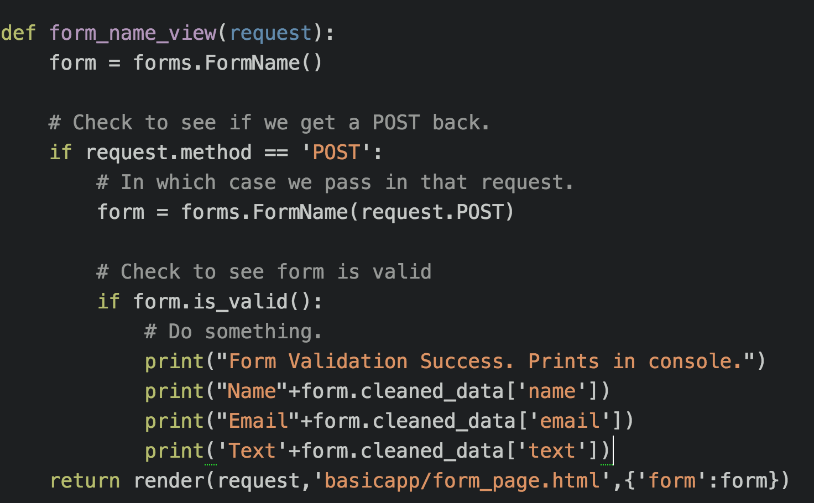

Let’s get some practice with what we know so far and create a basic form project and application from scratch. Once we’ve done that, we’ll revisit our original first_project and see how we can add a form that connects to a model.

# Django Level 3 – Hands on Django forms

1. Create a new project folder named “basicforms” under /Django/ directory. Then start a new Django project, named “forms” followed by starting an app named “basicapp” as shown below.



1. Next create a template folder in the “basicforms” directory, followed by a subdirectory with the application name i.e. “basicapp”.
2. Then create index.html and form_page.html files inside the above created directory ~/templates/basicapp/, as shown below.

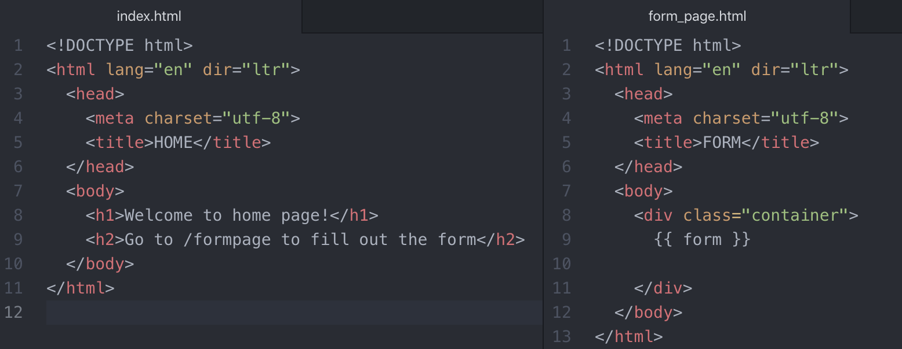

1. Go to settings.py file and setup the templates directory, and declare it under TEMPLATES list. Then, include the app name “basicapp” under INSTALLED_APPS list.
2. Inside the app directory “basicapp”, create a new file name forms.py

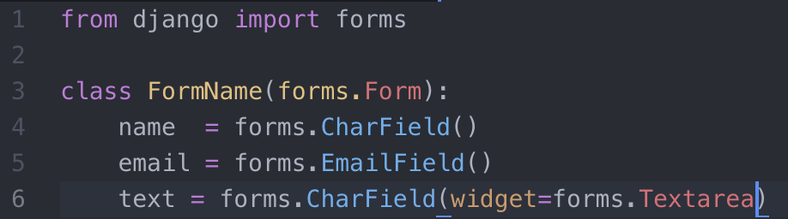

NOTE: line 6 shows how the text field is created in Django forms.

1. Set up the views for index and form pages, as shown below

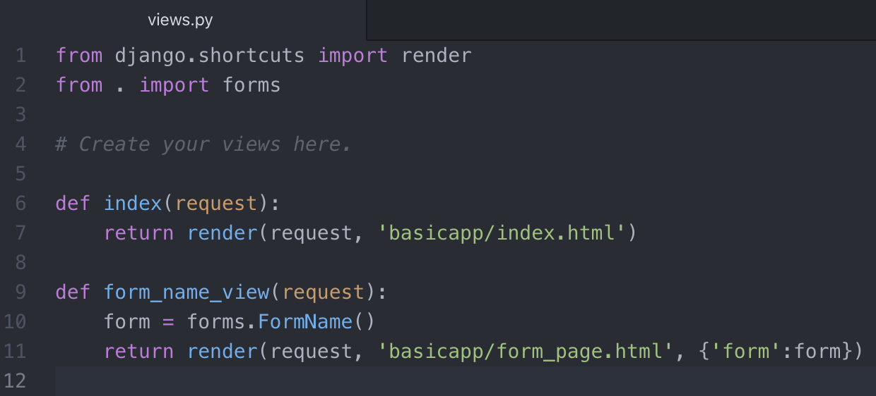

1. Set up the urls in the main project urls.py file.

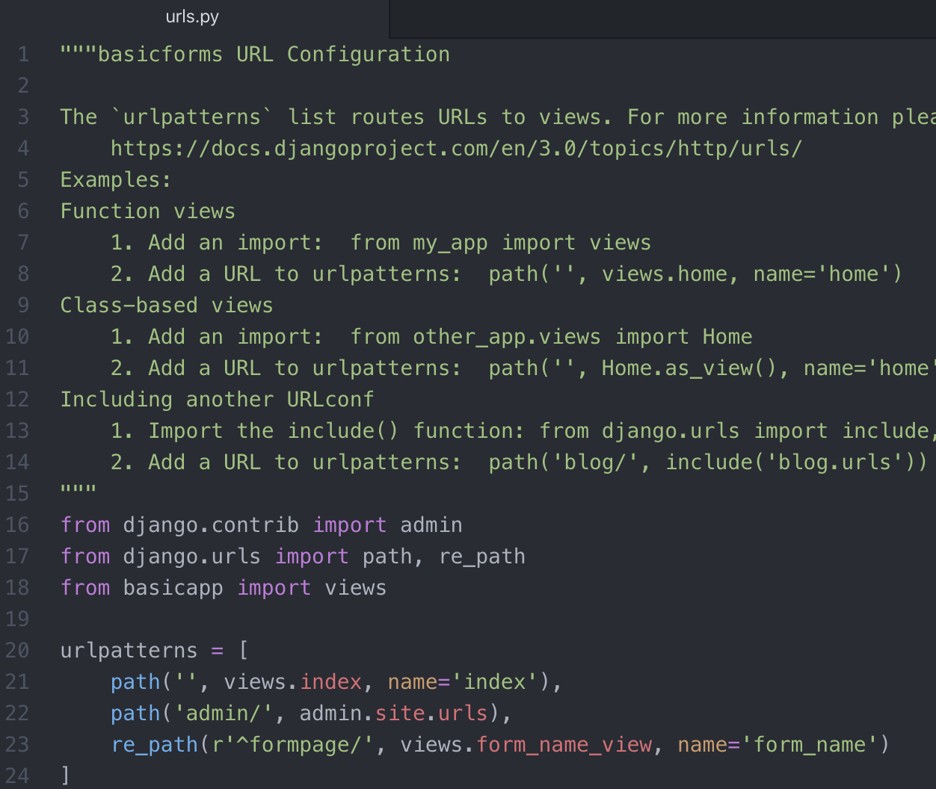

1. Now run the server using python manage.py runserver. Go to localserver/formpage and see a very basic and ugly form appear on your screen as shown below:

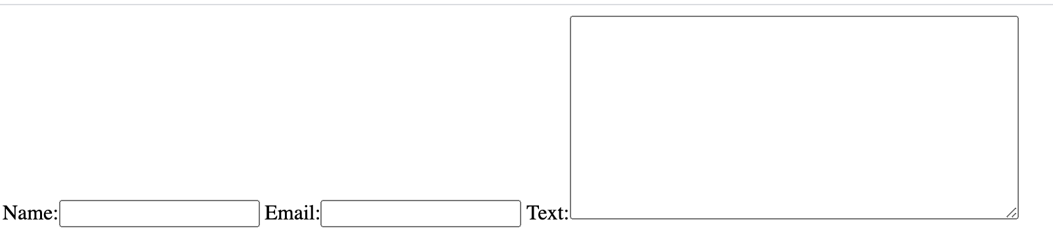

Now lets improve the form view.

1. Include the bootstrap link in both index.html and form_page.html page.
2. Initialize the <div> tag and declare it the class “container”. Nest another <div> tag and declare the class “jumbotron”.
3. On form_page.html page, create a <form> tag. For the time being, only keep the method field. Also bring the {form} tempalte tag inside the form html tag and use it with .as_p, as shown in the figure below.

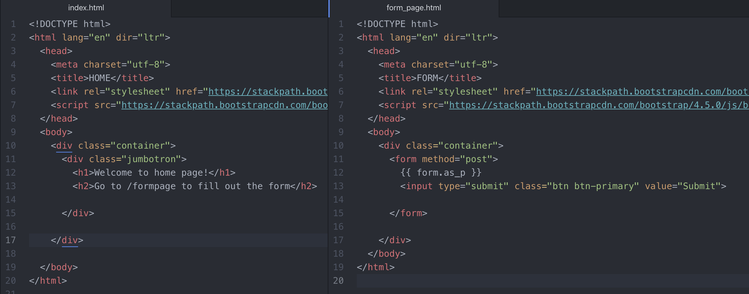

Now run the server and see the form looks much better as shown below:

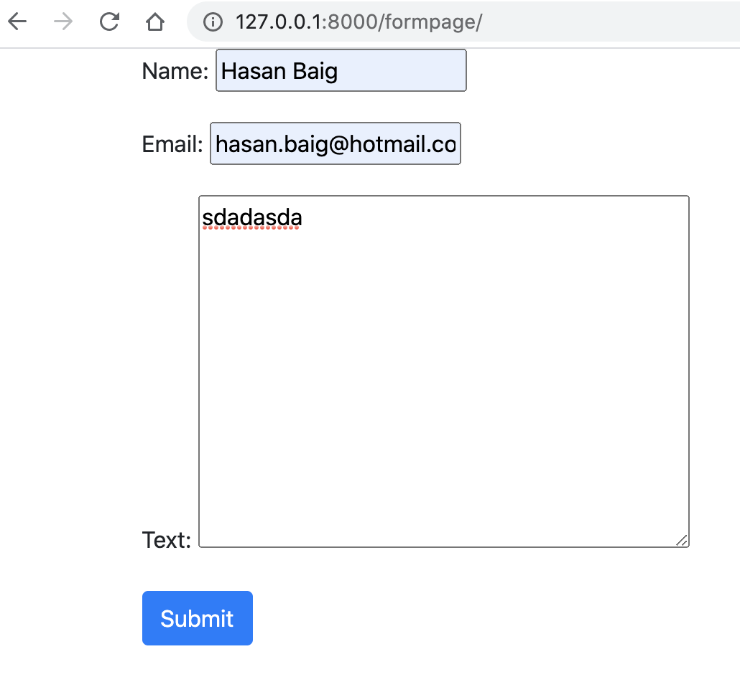

When we press the submit button, we get the following error, which arises because of the missing CSRF token.

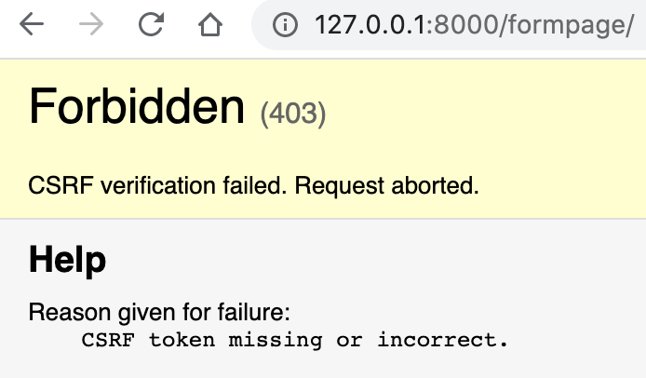

Therefore, after including the {% csrf_token %}, and submit the form, it is accepted and can be observed in the terminal as shown below, which shows that it accepts the submitted information:



Now in order to receive and play around with the data, we have to modify views. Modify the form_name_view defition in views.py file as shown below.

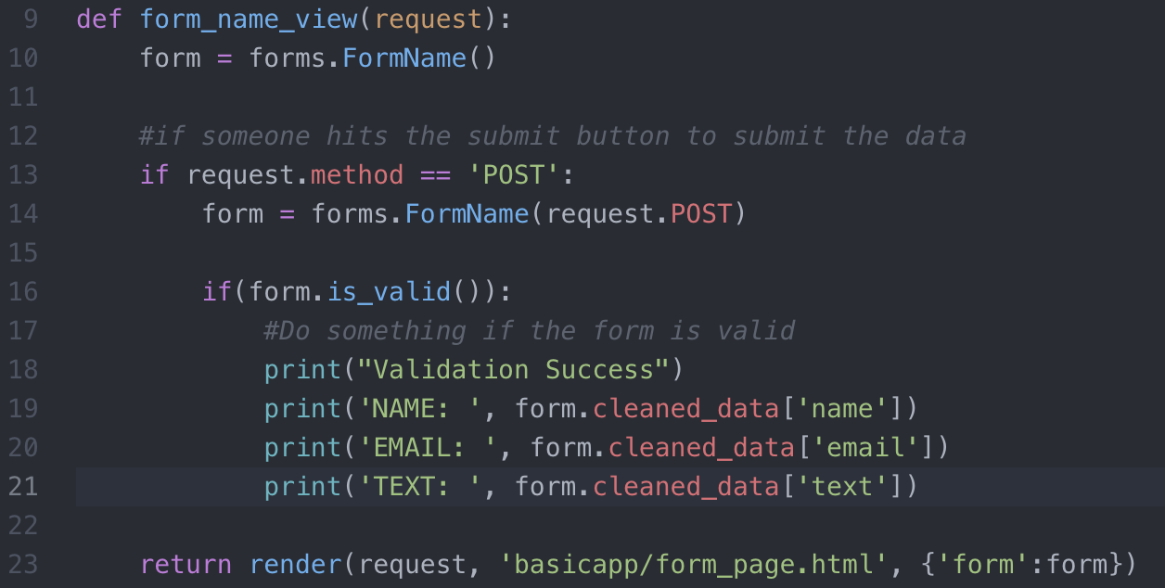

Now when you submit a form, the data will be printed on console as shown below:

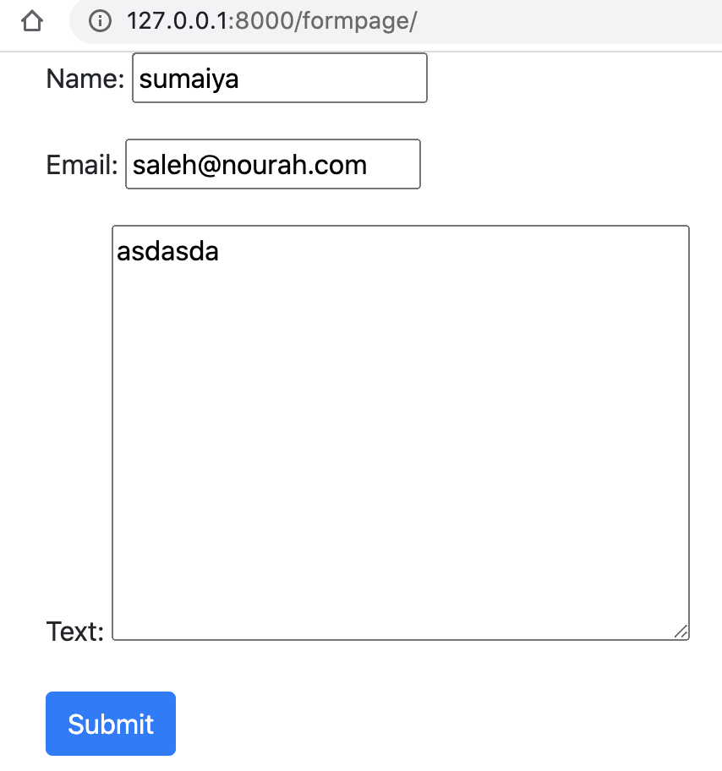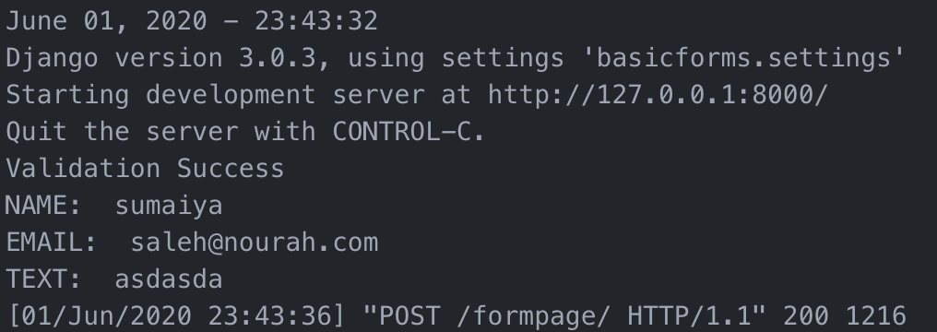

# Django Level 3 – Form Validation

Theoretical lecture about custom validators. Check the video lecture (136. Form Validation) for more details.

# Django Level 3 – Model Forms

# ­­To receive the data from user and save it into the database.

NOTE: There are few lectures which I did not document here but followed the exercise. Follow the videos on Udemy for more details.

From djangoproject.com   
Form Fields: <https://docs.djangoproject.com/en/3.0/ref/forms/fields/>

**\*\*\*\*\*\*\*\*\*\*\*\*\*\*\*\*\*\*\*\*\*\*\*\*\*\*\*\*\*\* Django Level 3 Ends Here \*\*\*\*\*\*\*\*\*\*\*\*\*\*\*\*\*\*\*\*\*\*\*\*\*\*\*\*\*\*\***

**\*\*\*\*\*\*\*\*\*\*\*\*\*\*\*\*\*\*\*\*\*\*\*\*\*\*\*\*\*\*\*\*\*\* Django Level 4 \*\*\*\*\*\*\*\*\*\*\*\*\*\*\*\*\*\*\*\*\*\*\*\*\*\*\*\*\*\*\*\*\*\*\***

In this section, will focus on learning a lot more about templates and templates tagging. So far, we have only used templates as a way of injecting simple pieces into our HTML files. But templates are actually capable of doing much more. For example, until now we have only been manually creating everything individually for each .html file. However, we can actually use templates to have a “base” template and inherit that template in the .html files. [This is very important from cloud copasi point of view because this has been implemented there.].

This saves a lot of time and will help create a unified look and feel across every page of your website. Templates:

* are also used to solve issues with relative paths and working with variables
* can also help solve issues by avoiding hard-coded URL paths
* also come with built-in filter capabilities so you can adjust variables on the actual individual page

## Relative URLs with Templates

So far when we’ve had to use an anchor tag with an href we’ve passed in a hardcoded path to the file (example: file path, bootstrap link etc). This is poor practice if we want our Django project to work on any system.

In this section, we will see how to use various methods to pass relative URLs with Templates. We will also study the preferred method that will be the main method used when future versions of Django are released.

NOTE: *Django generally has a really good roadmap for future releases, and every 2 years released a “LTS (Long Term Support)” version of Django, with support of at least 3 years.*

### Replacing a hardcoded URL path in href

We can replace the hardcoded URL path easily with the use of URLs in our templates. For example:

* <a href=”basicapp/thankyou”>Thanks</a>

Can be changed to:

* <a href=”{% url ‘thanku’%}”>Thanks</a>
  + Where, url is the keyword; and name=‘thanku’ is in the urls.py file.

It is also possible to just directly reference the view. For example:

* <a href=”basicapp/thankyou”> Thanks</a>

Can be changed to:

* <a href=”{% url‘basicapp.views.thankyou’%}”> Thanks</a>
  + Where, “thankyou” is the view defined in views.py file

However, this method of incorporating views directly will eventually go away with Django 2.0 in the future.

The suggested (and most future-proof) method to do all of this involves the urls.py file. Inside the urls.py file you add in the variable **app_name**. You then set this variable equal to a string that is the same as your app name.

Following is the best way to use URL templates:

* <a href=”basicapp/thankyou”>Thanks</a>

Can be changed to:

* <a href=”{% url‘basicapp:thankyou’%}”> Thanks </a>

This method requires that app_name variable to be created inside the urls.py file!

The usage of templates for relative URLs is really helpful in a project having multiple Django Applications, like Cloud Copasi. For now, we can practice here with a basic example.

## Relative URLs Coding Practice

Create a new Django project “learning_template” from scratch under ~Django/ directory.



Also, create the templates/basic_app directories, and then define the TEMPLATES_DIR, include the app name in INSTALLED_APPS dictionary, and the TEMPLATE_DIR name in the TEMPLATES dictionary; all in settings.py file.

Now, in order to practice url templates, we need to have couple of html files.

1. Create the following four html files under ~templates/basic_app/ directory
2. base.html
3. index.html
4. other.html
5. relative_url_template.html
6. Leave the base.html file for now, and add the following contents in the respective files.

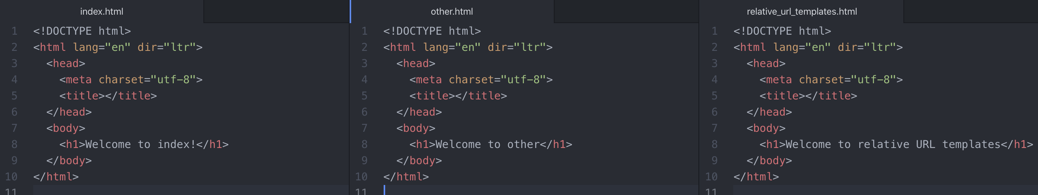

1. Now modify the views.py file as shown below

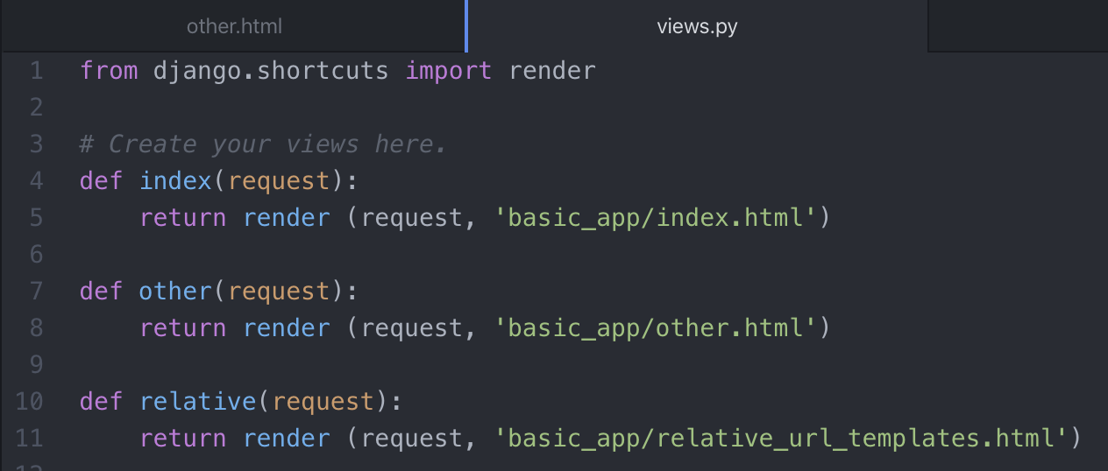

1. Now setup the urls file to point to these views

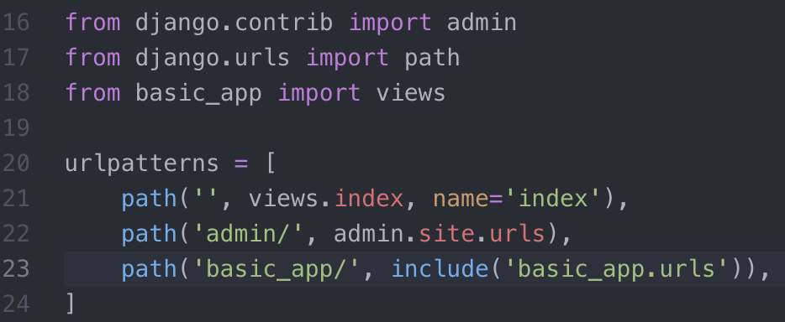

Here,

Line 21: whenever someone visits your page, take them to index.html page.

Line 23: if someone wants to visit any page related to basic_app/~ then retrieve corresponding views from “urls.py file defined inside basic_app folder”.

1. The url file defined inside ~/basic_app/ directory is shown below.

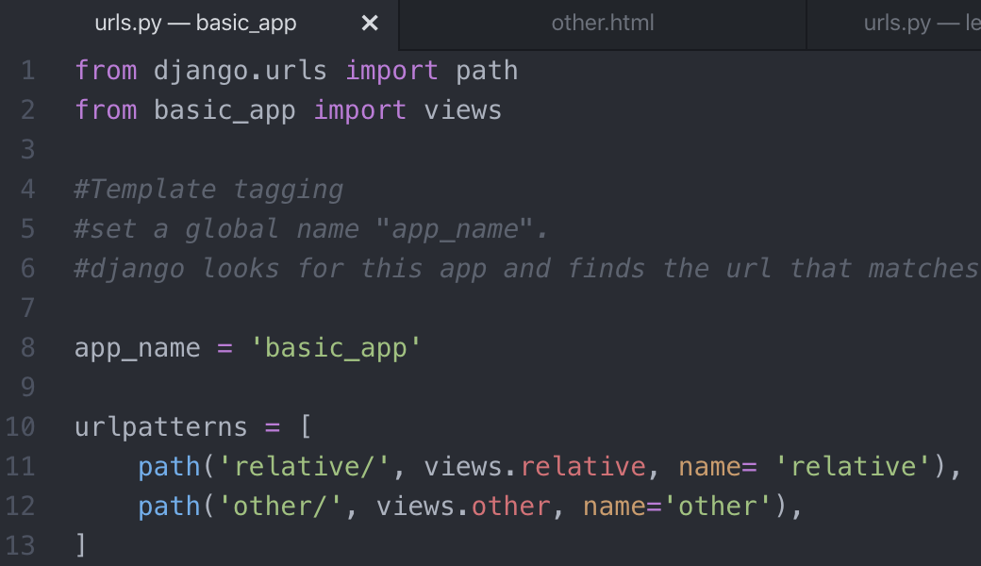

1. Now come to relative_url_template.html to implement the templates. Code as shown below. As shown in the figure below, ‘basic_app” in line 13 in relative_url_templates.html file should match to the value defined in line 8 in urls.py file (inside the app folder). Similarly, name of view in line 13 should match with the name of url page ( in ~/basic_app/urls.py) we want to display.



NOTE: no space should be given in 13 after/before single quotes. ‘basic_app:other ’ 🡪 this may lead to an error.

1. Run the server now and verify the functionality



Another example is to include the admin page template tag as shown below. The “admin” is a default app included by Django and can be seen listed in settings.py file under INSTALLED_APPS dictionary.

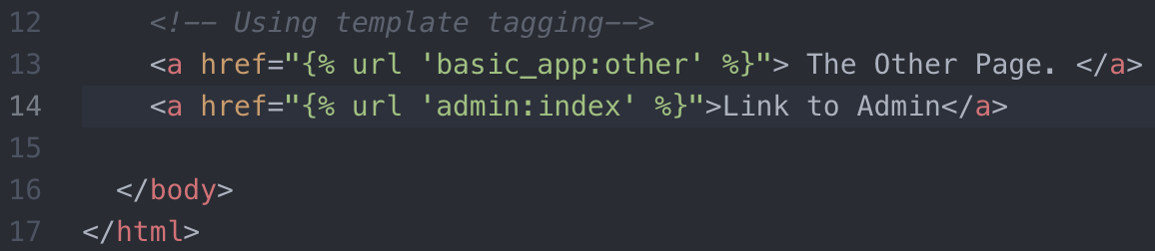

Including admin view, may require migration. Migrate first and then run the server again to verify the functionality of admin page being included.

Now include an index page and verify the functionality.



## URL Template Inheritance

In this section, we will learn how we can use Django Template Inheritance to practice DRY (Don’t Repeat Yourself) coding principles. Template inheritance allows us to create a base template we can inherit from. This saves us a lot of repetitive work and makes it much easier to maintain the same base look and feel across our entire website. For example, if we wanted a navbar at the top of our page, it wouldn’t make sense to continually have the same navbar HTML code in each individual .html file. Instead we set it to the base.html file and inherit it using template inheritance.

This idea is sometimes also known as template extending, as in extending the base.html to other .html files. The inheritance doesn’t need to just be limited to one base.html file, you can extend multiple templates

Before creating any Django Project, it is always a good idea to sketch out the main idea and organization by hand. This will help you realize what can be used for template inheritance and what applications you should create.

### Steps of Template Inheritance

* Find the repetitive parts of your project
* Create a base template of them
* Set the tags in the base template
* Extend and call those tags anywhere



In the example shown above, the left side shows the base.html file which contains the links to Javascript, CSS, Bootstrap etc. Then we have an html related to nav bars etc which we want to be displayed on every html page for our website.

Then inside the body, we have the stuff which we don’t want on every single page. We represent such stuff with the following tags

{% block body_block %}

{% endblock %}

Then we have html related to footer etc. The {%block%} tag allows us to inject the contents from other html files. For example, in the file shown on the right-hand side extends the base.html file. Then insert the contents of a block. Everything outside the {% block %} tags in base.html file will be inserted to other.html file.

### Practicing the template inheritance

1. Link to Bootstrap
2. Design the navigation bar with the help of bootstrap documentation.
3. Whatever body content you want to display on other pages, should be contained inside a <div class=”container”>.

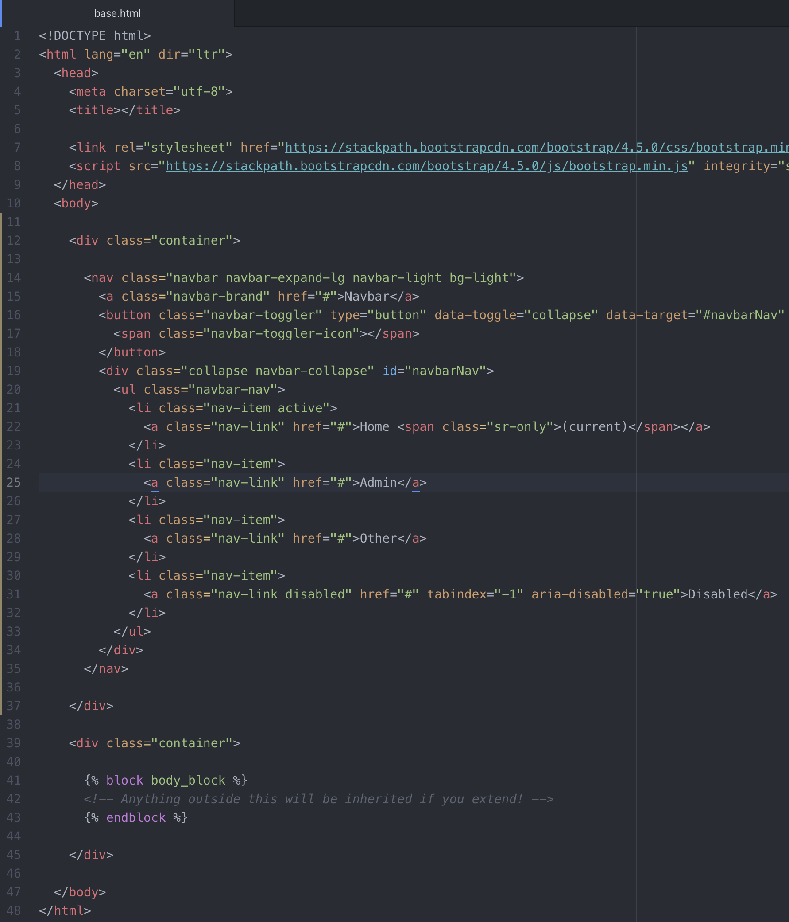

NOTE: The template highlighting is enabled when you install “Django-template” extension in atom.

1. Now open other.html and index.html files and make them look like this:

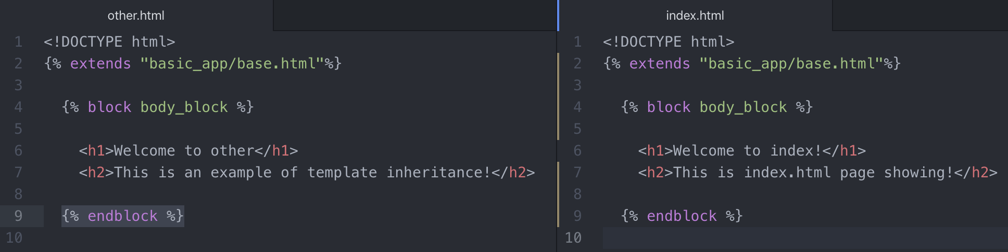

1. Now run the server and verify the functionality as shown below:



1. We now need to have the navigation buttons connected to respective pages. Go to base.html file and pass the respective url template tags in the href tags of each navigation button as shown below:



NOTE: No matter it the html file is the base.html, or any other in which the base.html is extended; the important thing is to include the <!DOCTYPE html> tag in all of them.

## Template Features and Custom Filters

Imagine that you had some information from your model that you wished to use across various views/pages. But perhaps you wanted to make a slight edit to the information before injecting it, like string operations, or arithmetic. Luckily Django provides a ton of easy-to-implement template filters that allow you to effect the injection before displaying it to the user. This allows for flexibility from a single source, so we do not need to edit the source from python side, and we can just simply edit it from the website.

The general form for a template filter is:

{{ value | filter:”parameter” }}

* Value 🡪 to be injected
* Name of the filter and parameters
* Not all filters take in parameters.
* Many of these filters are based off of common built-in Python functions so you will be already familiar with them
* Get to know more about Django Templates at <https://docs.djangoproject.com/en/3.0/topics/templates/>

Example:

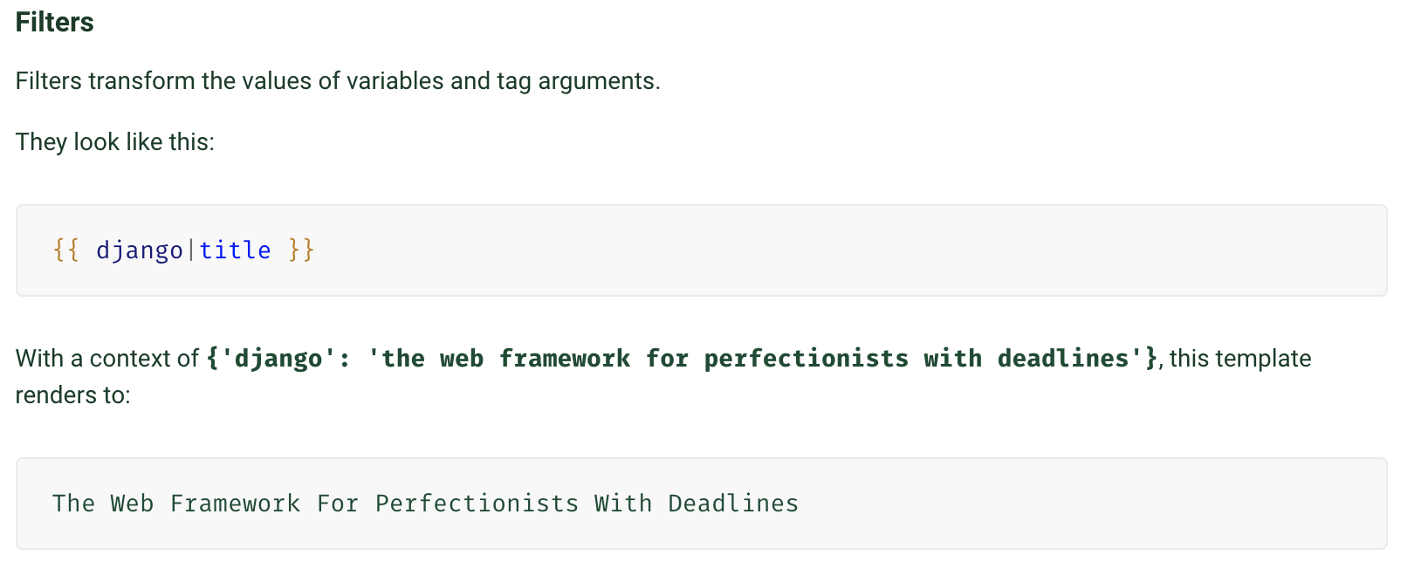

Here, “django” is a dictionary key, and the “title” is the filter name we are using. This will convert the corresponding value of Django to “title” which capitalizes the first letter of each word. Look for more built-in filters at <https://docs.djangoproject.com/en/3.0/ref/templates/builtins/#ref-templates-builtins-filters>

### Template Filters Coding Example

We will be injecting filters in the index.html page in the same project we have been currently working upon. Before doing that, we need to add a context dictionary in index view under views.py file. Modify the definition index as shown below:

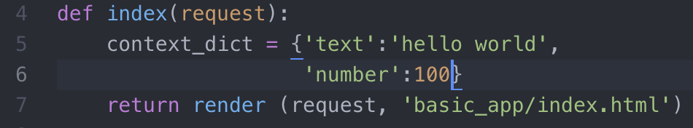

Now jump to index.html page, add the following filter tags, and run the server to see the results shown on the right side of the following image.

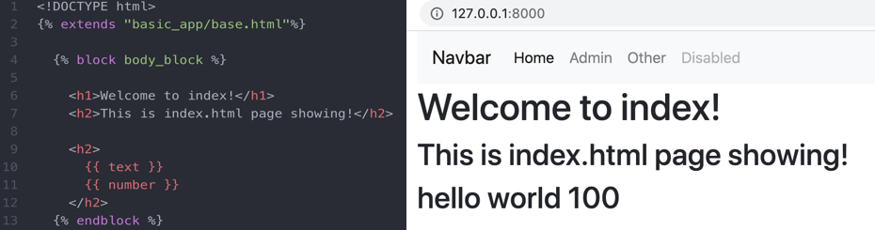

Now these filters do not have any parameters yet. We can now perform most of the python methods on these filters. Lets try adding the “string.upper()” python method on the text of filter, as shown in line 10 below. We can also perform arithmetic operations on the values. For example, the value of number (key) dictionary item is 100. We can add 10 to this value as shown in line 11 below. The results are shown on the right-hand side.



So most of the time we can find the built-in filter to serve our need. However, sometimes we need perform customized operations for which we can create the customized filters. We can create our own function to work with that filter.

In order to do this, we will follow the convention of setting up the folder inside the Django “application” folder with name tamplatetags. Create a file in it __init__.py, which tells python to treat this file as a module. The file name of custom templates could be my_extras.py.

Now code the custom filter as shown below:

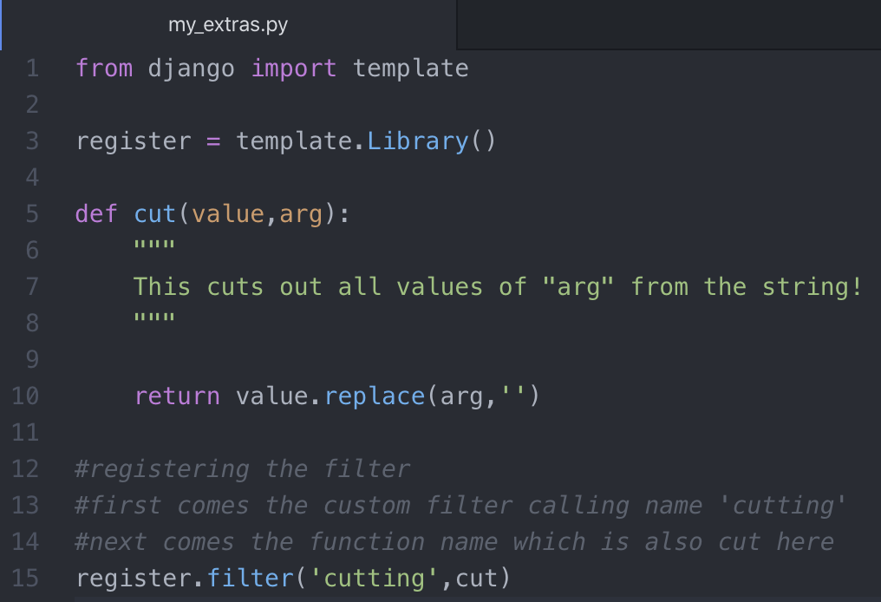

Registering the filter using decorator.

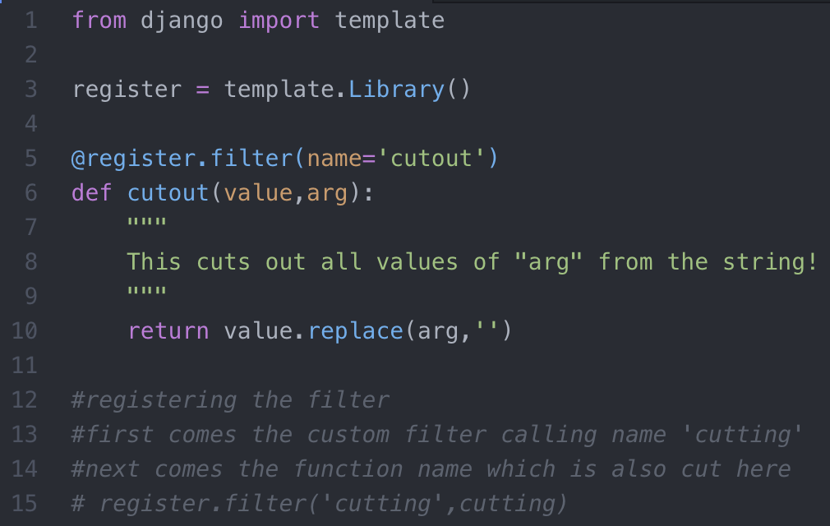

Now go back to index.html page and call this customized template filter there.

It is important to include {% load myextras %}, as shown in line 3 below. It loads the filters where the filter definitions are defined.

CAUTION: You have restart the server after defining custom filters.

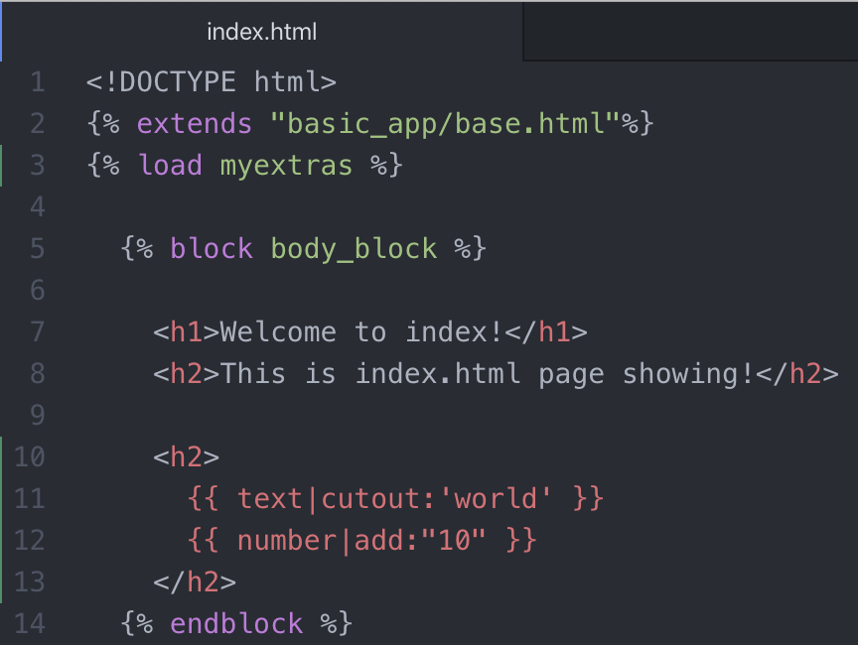

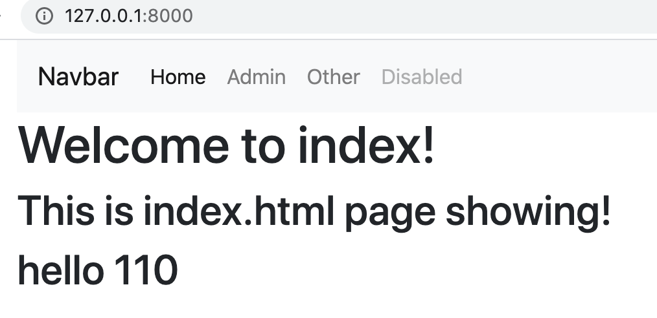

**\*\*\*\*\*\*\*\*\*\*\*\*\*\*\*\*\*\*\*\*\*\*\*\*\*\*\*\*\*\* Django Level 4 Ends Here \*\*\*\*\*\*\*\*\*\*\*\*\*\*\*\*\*\*\*\*\*\*\*\*\*\*\*\*\*\*\***

**\*\*\*\*\*\*\*\*\*\*\*\*\*\*\*\*\*\*\*\*\*\*\*\*\*\*\*\*\*\*\*\*\*\* Django Level 5 \*\*\*\*\*\*\*\*\*\*\*\*\*\*\*\*\*\*\*\*\*\*\*\*\*\*\*\*\*\*\*\*\*\*\***

# Django Level 5 Introduction

So far, we’ve only created applications that assume everyone will see the same page. This section of the course will focus on User Authentication. This is one of the aspects of Django where there are lots of built in available tools as well as plenty of external packages that enhance functionality. We will focus mainly on the built-in tools:

* Users and the User Model
* Permissions
* Groups
* Passwords and Authentication
* Logging In and Out

## Passwords

In this section, we will discuss the general set-up to begin getting ready for User Authentication. We’ll talk about passwords in general and also discuss some additional library options for security.

### User Authentication

The first thing we need to take care of is setting up our ability to authenticate a User. To do this we need to use some built-in apps and make sure they are under the INSTALLED_APPS list in settings.py. The apps we will use are:

* “django.contrib.auth” and
* “django.contrib.contenttypes”

Often these will already be pre-loaded in the list for you.

Note: Remember to migrate if you added them.

The next thing we need to do is make sure we store our passwords safely. **Never store passwords as plain text.** We will begin by using the default PBKDF2 algorithm with an SHA256 hash that is built-in to Django. This is quite secure for most applications, and it requires a massive amount of computing power to crack it. But if you want more security you can upgrade to even more secure hashing algorithms.

Django makes this really easy; we will also show how to use the bcrypt and Argon2. In your virtual environment:

* + >> pip install bcrypt
  + >> pip install django[argon2]

Depending on your Django version you may already have these installed.

Inside of **settings.py** you can then pass in the list of PASSWORD_HASHERS to try in the order you want to try them. If for some reason you don’t have the library support, eventually you will fall back on to the original PBKDF2.

Sometimes users will also try to use a very weak password, such as “password123”. We can also add in validator options to prevent a user from doing that. We’ll keep things simple and only require a minimum length for now.

Let’s now code through the steps of setting up a password system. After this we can set-up our User Models and our Registration Forms.

### Secure Hash Algorithm (SHA)

Go to the following link and observe the code being generated by SHA algorithm for the character “A”. If we add another character (or a special character), the code will be entirely different.

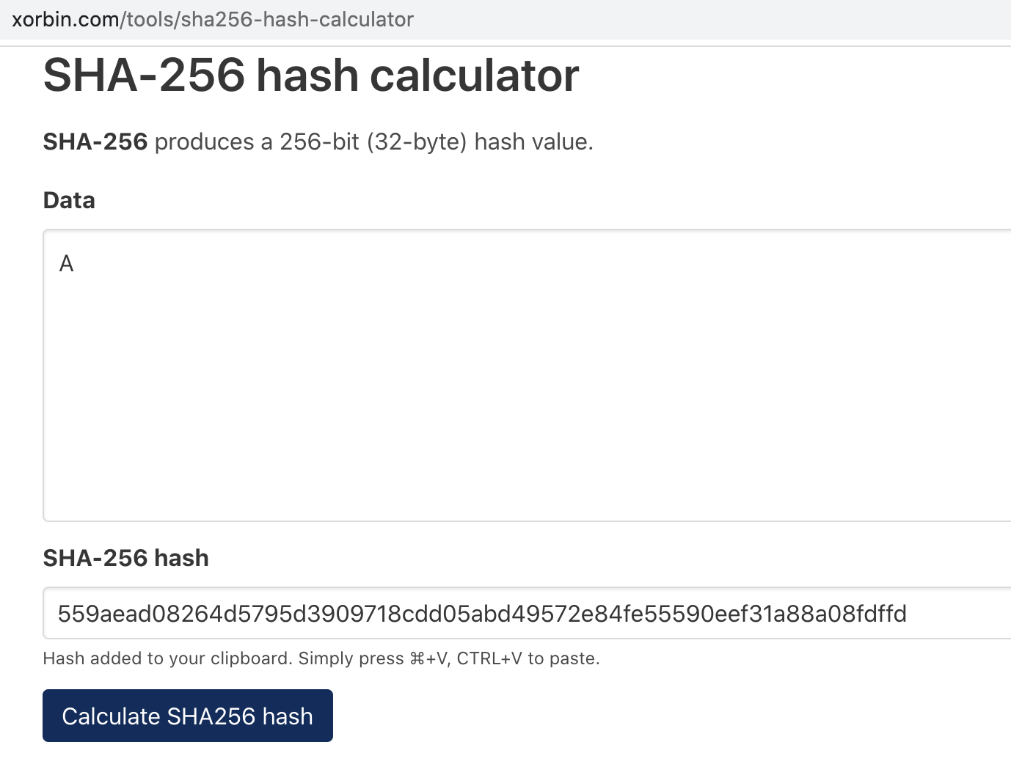

SHA is designed by National Security Agency (NSA). It is a cryptographic hash function. Users will input the password, and we will be saving the hash of that password. If someone cracks the database, they will not be able to determine the password.

### Hands on exercise

Create a new folder “~/Django/Django_level_five” and start a Django project named “learning_users”; and then inside the project directory, create a new Django project app named “learning_users”, as shown below.



Now scroll down to settings.py and check the INSTALLED_APPS dictionary if the following three apps are included

1. django.contrib.admin
2. django.contrib.auth
3. django.contrib.contenttypes

Also add ‘basic_app’. Now, migrate the project. And make migrations on the ‘basic_app’.

>> python manage.py migrate

….

>> python manage.py makemigrations basic_app

Then run the migrate command again to make sure that “No migrations to apply”.

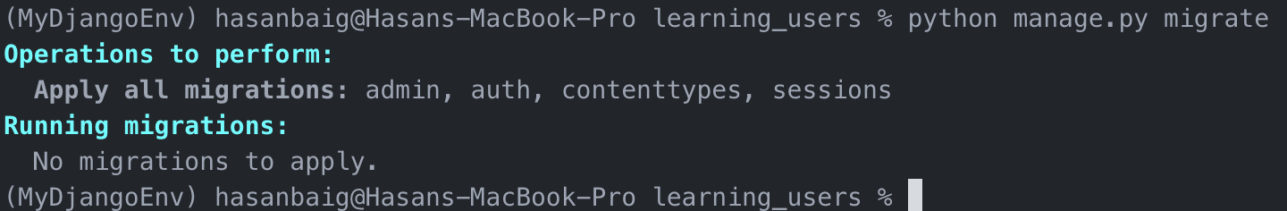

Now, we don’t want to store passwords as a text file. We want to store the password’s hash file for which we need to install the libraries of that algorithms. So install the following libraries one by one.

>> pip install bcrypt

>> pip install django argon2

Now in the settings.py file, we have to pass in a list containing the password hashes we want to try.

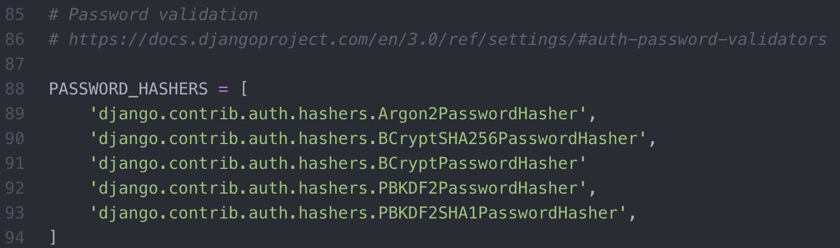

In the image shown above, many different layers of password encryption is added, which will be executed in sequence. So for example, the most strongest password hasher Argon2 will tried first. If, for some reason, it is not installed on the server, then the next one is tried, and so on.

Now next comes the password validators. There is already a list of dictionaries defined for this at line 96 as shown below. The first library verifies for the similarity between the user name and password; second one make sure the password fullfils the minimum length requirement; third one looks for the common password (like password123 etc); the fourth one required the presence of numeric digits in the password.

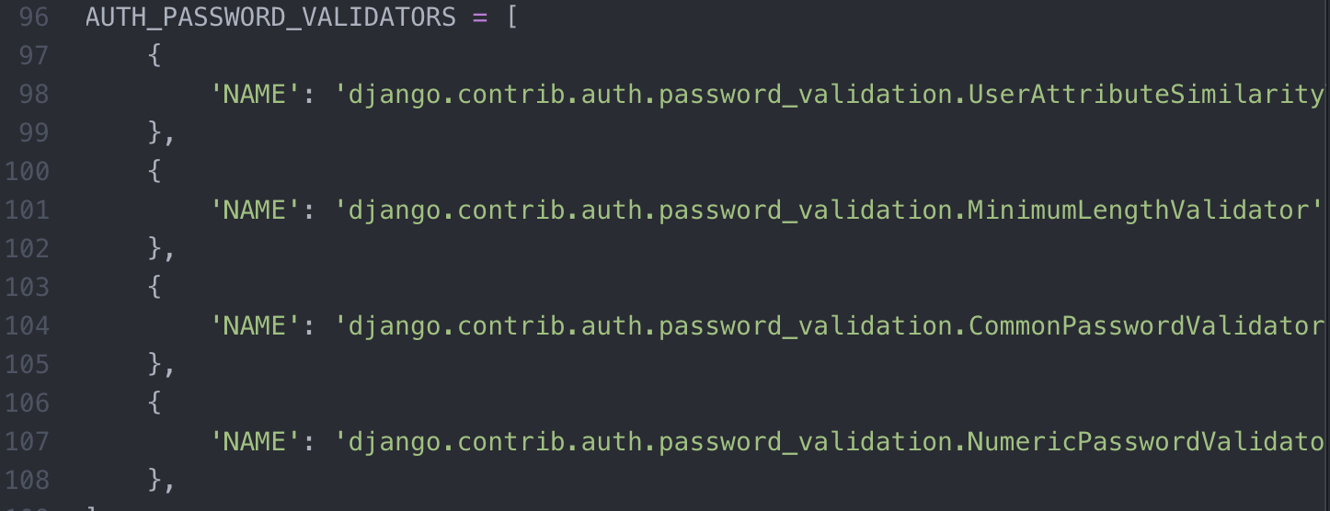

Now we will modify these dictionaries to use these options. For example, in the minimum length validation, we add another key, named OPTIONS, and the value of which contains another dictionary to add different options, as shown below.

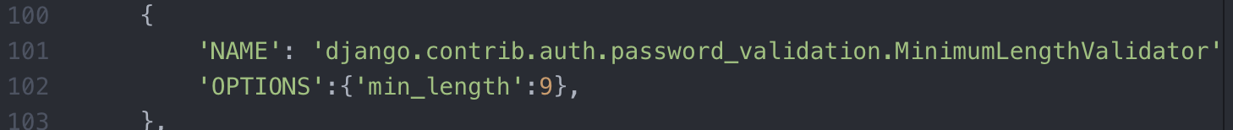

NOTE: Look at the documentation for various options at <https://docs.djangoproject.com/en/3.0/ref/settings/#auth-password-validators>

This is all what we need to do for setting up the passwords in settings.py. Before moving on, we can also setup TEMPLATE_DIR and other directories here.

First create the following three directories under ~/Django/learning_users/ directory.

1. templates: to hold the html templates
2. static: to hold the files by developers (e.g. logo etc)
3. media: to hold the files by users (for example user profile pic)

Once created, setup the directory paths in settings.py as shown below:

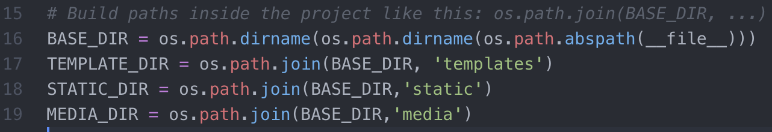

Also, declare the TEMPLATE_DIR, STATIC_DIR, and MEDIA_DIR shown in the following images repectively.

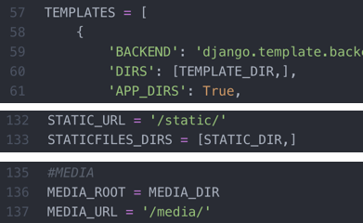

## Users Model

In this section we will discuss how to use Django’s built in tools to create User Authorization Models. We will also discuss how to set-up media files in our project.

Previously when we’ve logged on to the Admin page, we’ve seen that there is already a built-in Authentication and Authorization model set in place. In this database there were “Users”. Let’s learn how to use this feature!

The Django built-in **User** object has a few key features:

* Username
* Email
* Password
* First Name
* Surname

There are also some other attributes for the **User** object, such as

* is_active,
* is_staff,
* is_superuser.

Sometimes you will also want to add more attributes to a user, such as their own links or a profile image, etc.. We can do this in your applications models.py file by creating another class that has a relationship to the **User** class. Consider the following example:

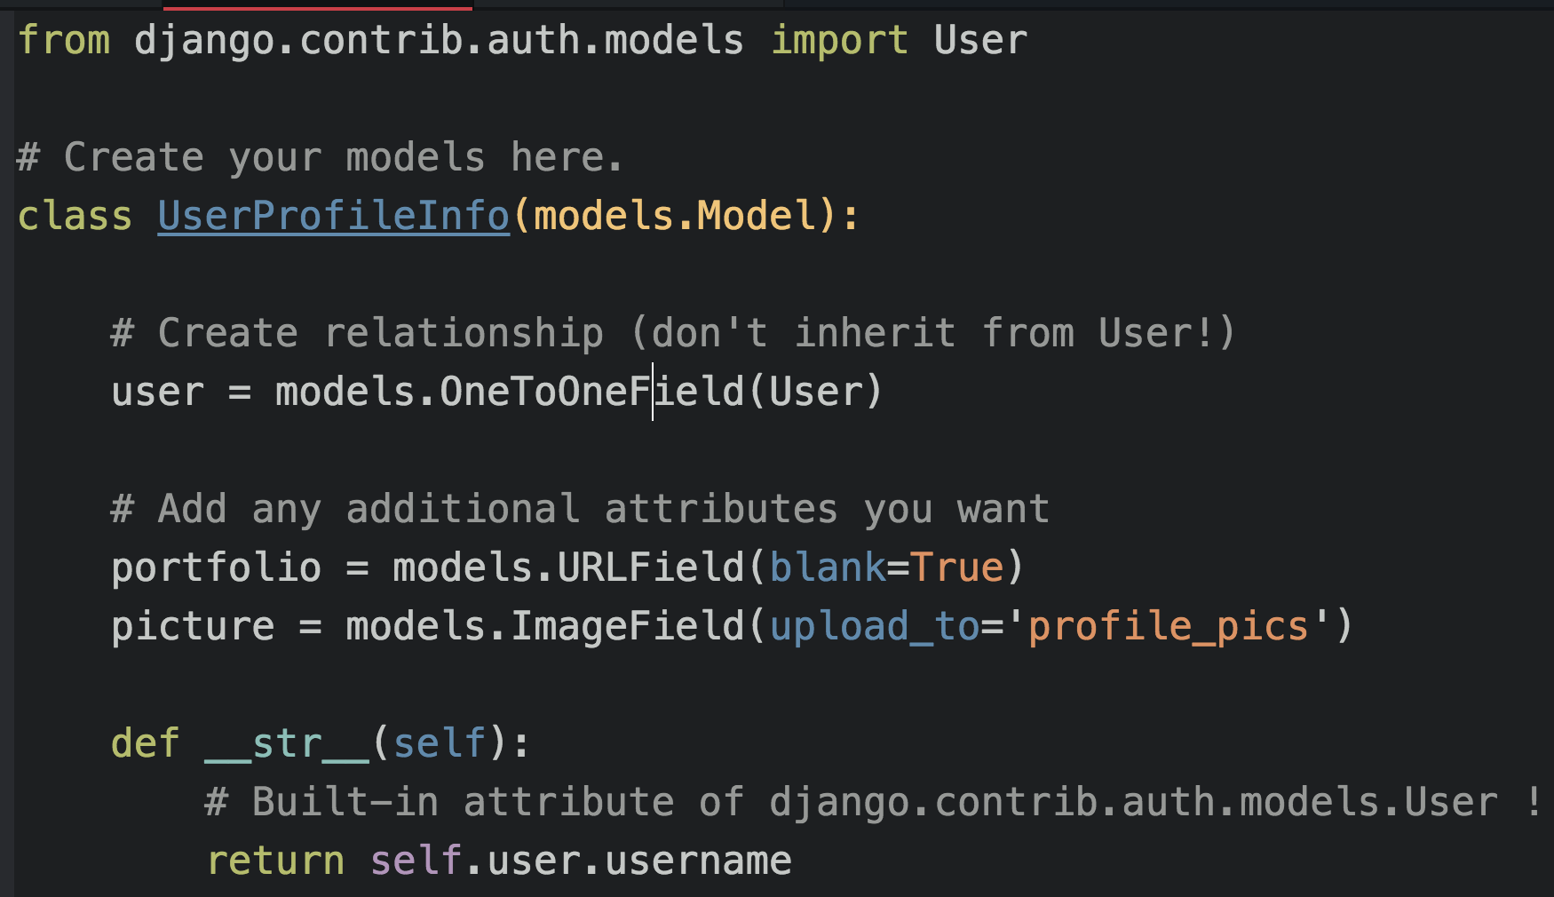

First we import the model User from “Django.contrib.auth.models” library.

Next we create our own model named “UserProfileInfo”.

Next, instead of directly inheriting from User, we create a one-to-one field connection with the “user” model.

Then we add in the additional attributes. As mentioned above, the base user model has the basic features like Username, email, password, first name and surname. If we would want to add any additional features, we should use this OneToOneField relationship. So here we add two more attributes for users – URL (for user’s personal portfolio) and image field (for user’s profile picture).

Then the string method is used to printout the username.

Notice a new field we haven’t seen yet, an ImageField. This will allow us to store images to a model, typically we will keep any user uploaded content like this in the media file.

In order to work with images with Python we will need to install the Python Imaging Library with:

>> pip install pillow

If you get an error on this command indicating something like jpeg support disabled, in which case use:

>> pip install pillow --global-option=”build_ext” --global-option=”--disable-jpeg”

Once we have created this model, we will have to remember to register it in the admin.py file, with something like:

* admin.site.register(UserProfileInfo)

Typically, images, CSS, JS, etc. all go in the static folder of your project, with the STATIC_ROOT variable path defined inside of settings.py. User uploaded content will go to the media folder, with the MEDIA_ROOT.

Next we will want to implement a Django form that the User can use to work with the website. Let’s show an example of what this would look like inside the forms.py file of our application.

The code inside forms.py file is shown below:

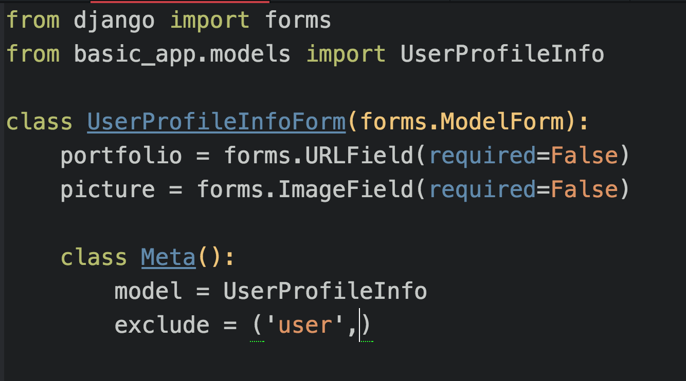

Let’s now code through the set-up of what we’ve discussed:

* User Model
* Media Directory
* Handling Images
* User Form

Once we’ve done that, we can begin to focus on creating a registration view.

## Hands on User Models and Forms

1. Open the models.py file and create a user model as discussed above.
2. Also create a folder under media with a name “profile_pics”

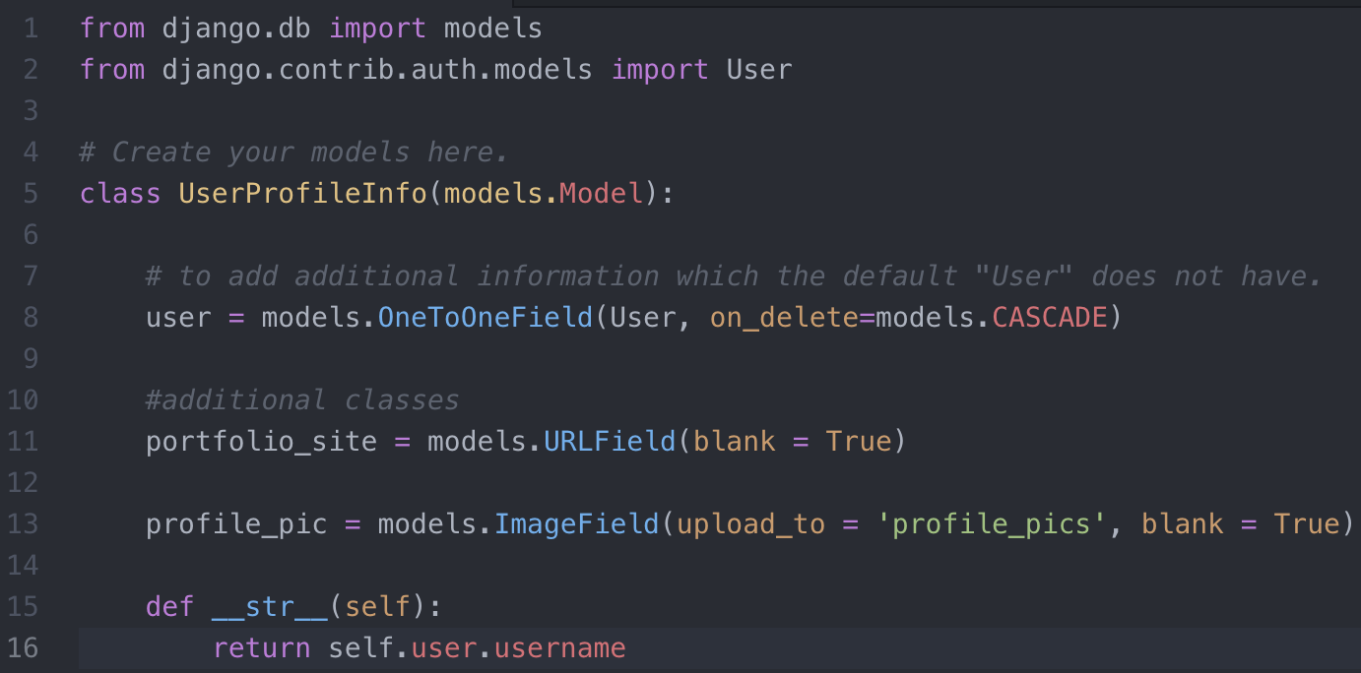

1. Install pillow library
2. Create a form for models.py. Create a new file forms.py inside the application folder i.e. ~/basic_app/

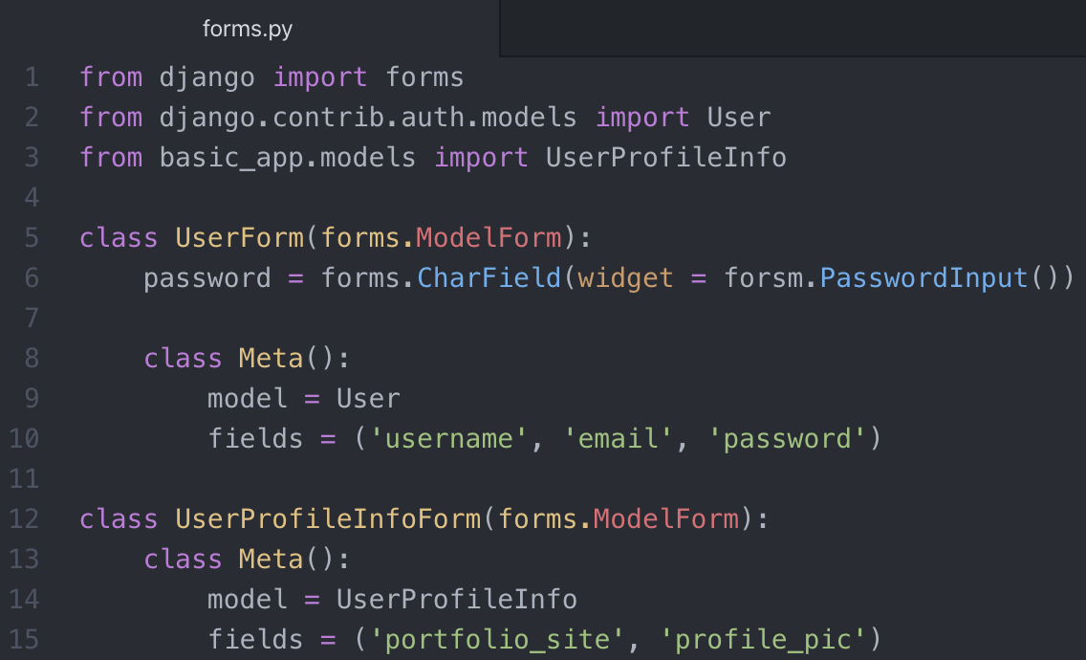

1. Now we have to register the form in admin.py to let the admin see it with admin access.

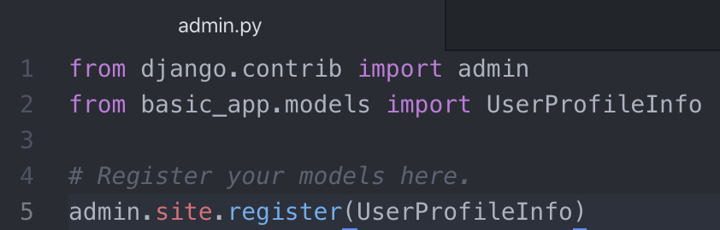

1. Migrate; makemigrations basic_app; and migrate again.
2. Now create the following html files inside ~/learning_users/templates/basic_app/ directory
   * base.html
   * index.html
   * registration.html
   * login.html (we will deal with this file later in the end)

First create a base.html file as shown below

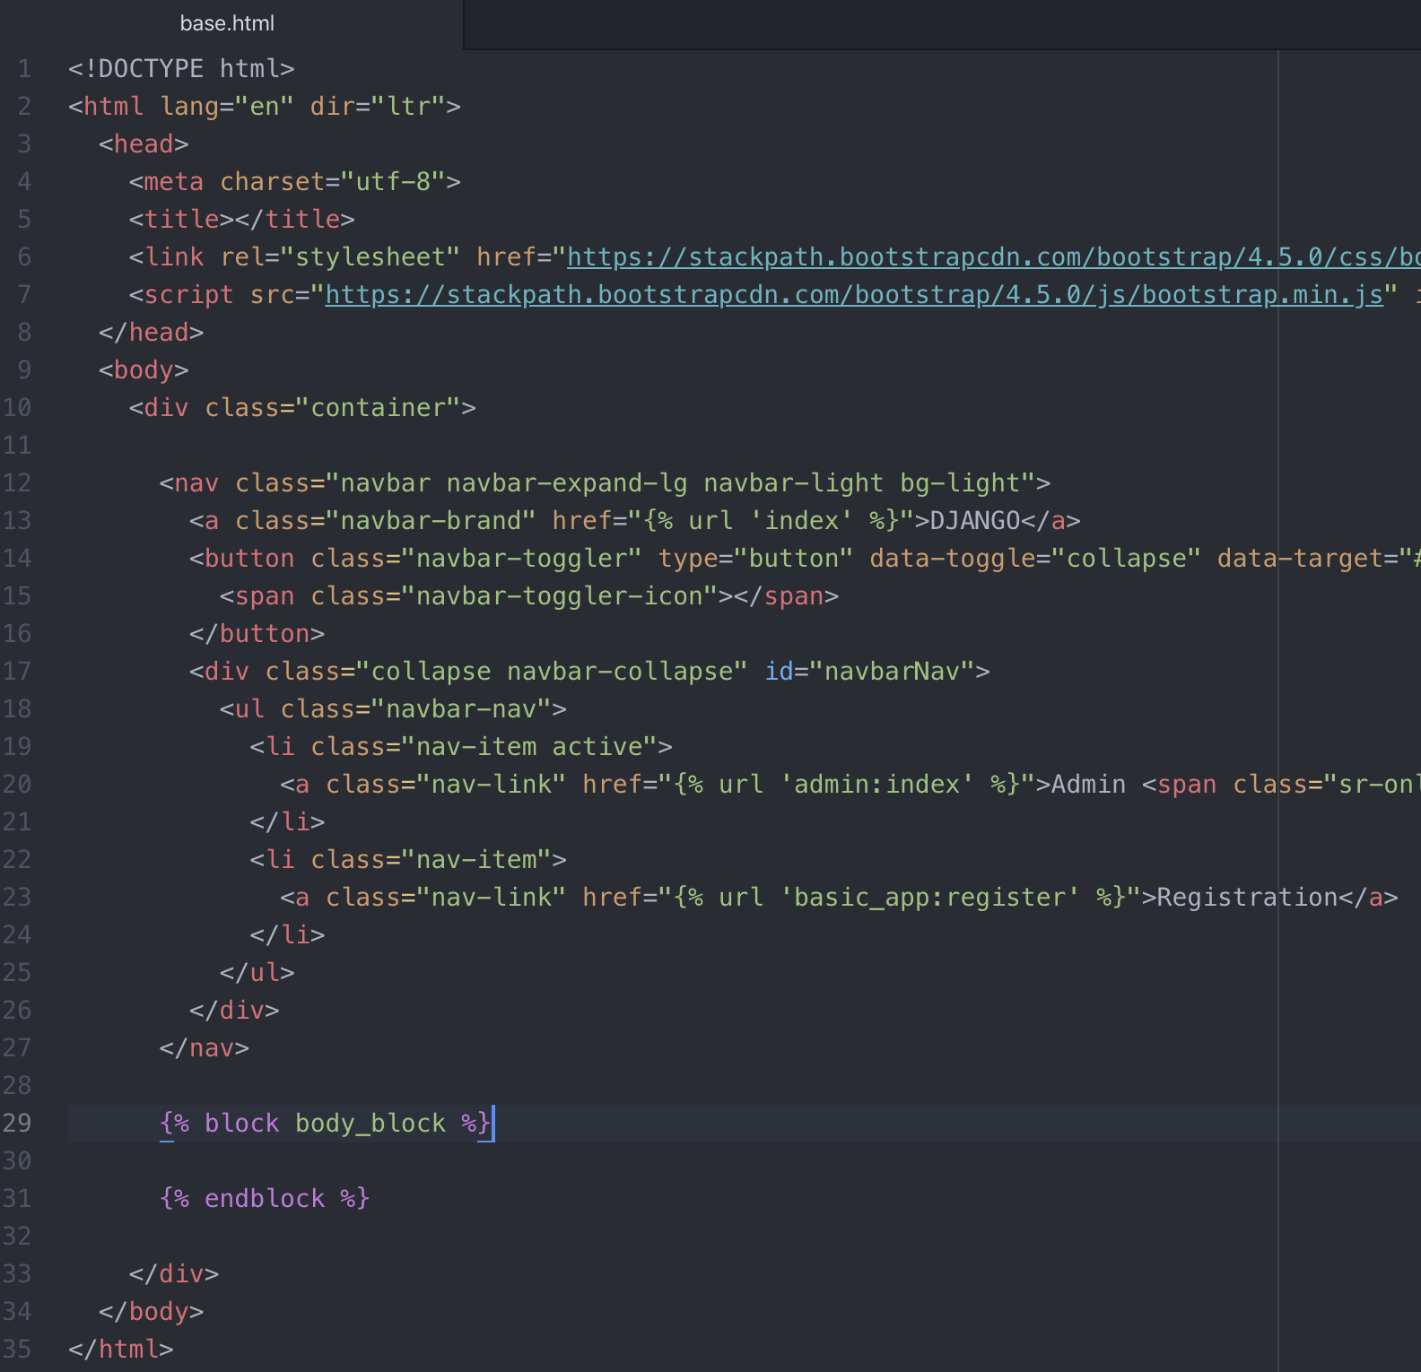

Next, create index.html

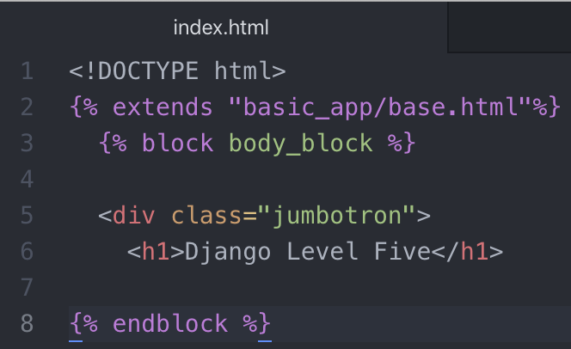

Now, create the registration.html file as shown below:

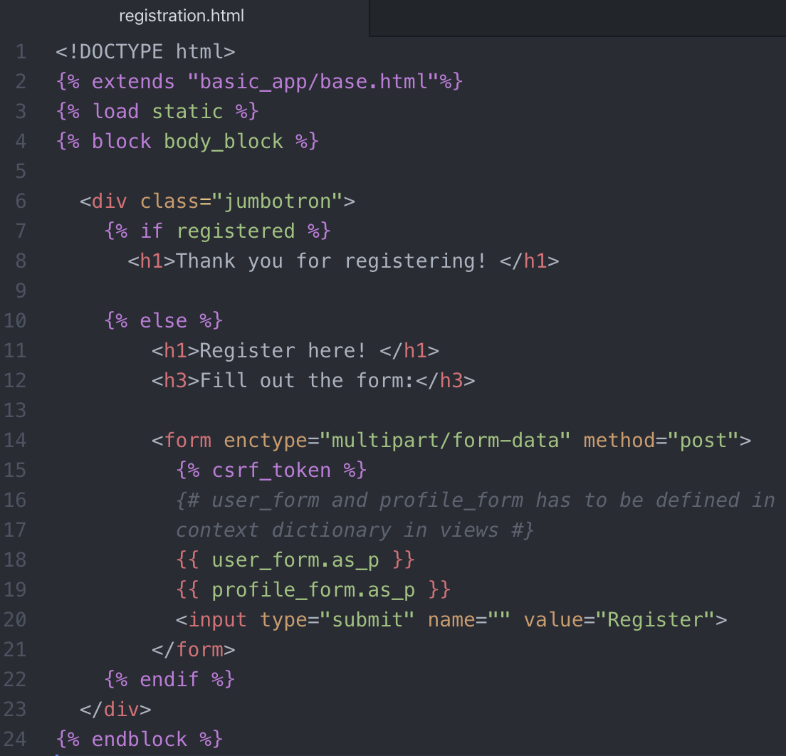

CAUTION: Line 3 was earlier defined as {% load staticfiles %}, which is depricated in Django 2.1 and removed in Django 3.0. Therefore, it is replaced with static.

We might be in a need of static files so include the template tag of loading staticfiles at the top.

Then we create a form. We do neither need a class nor an action right now, so we will remove these fields; set the method type to “post”. Since we are using multimedia type data in forms (to allow user to upload image files), therefore we need to include the field “ enctype="multipart/form-data" “.

CAUTION: enctype="multipart/form-data" should be included otherwise image uploading won’t work.

Now we need to edit the project’s urls.py file, as well as add a new urls.py file of own app.

learning_users/urls.py

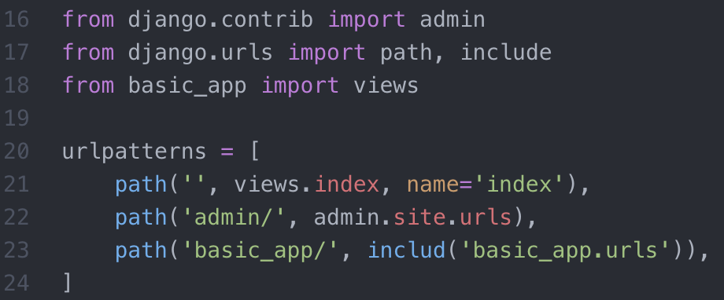

/basic_app/urls.py

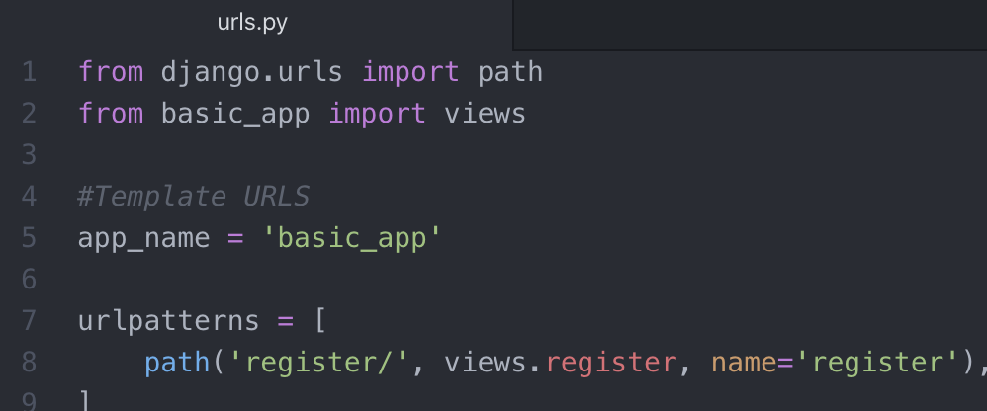

Next, we have to create views in views.py file and setting up the registration.

## Registrations

A lot of the coding for working with Users and Authorization happens in the views.py file. The basic idea is that we check if there is a POST request and then perform some sort of action based off that information.

Sometimes we will want to save that information directly to the database. Other times, we will set commit=False so we can manipulate the data before saving it to the database. This helps prevent collision errors for saving it twice.

Figuring out the registration views is an extension of what we learn about when discussing Django Forms. So, make sure to review that content if you don’t remember it. This entire process is best shown through code, so let’s jump to our views.py

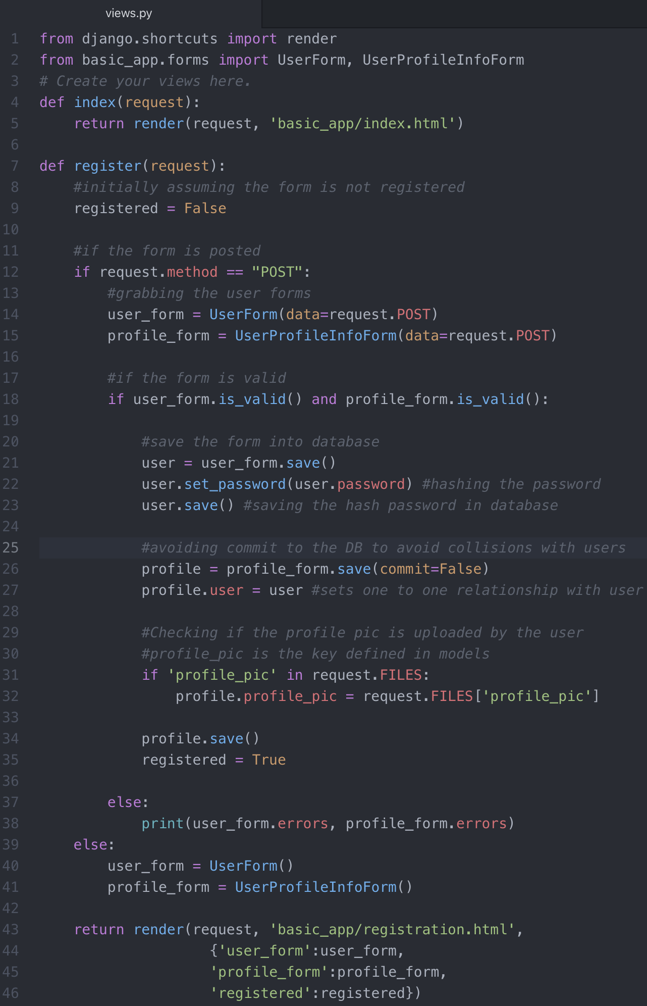

In line 43, we need to pass along three different keys in context dictionary, which we have defined in the registration.html file ({% if registered %}, {{ user_form.as_p }}, {{ profile_form.as_p }}).

Now, migrate; makemigrations; migrate again.

Run the server to verify the functionality.

### Verification

Now when we try to fill out the form, we see that the following things happen:

1. the complete link including https://www.etc.com for the portfolio link.
2. When the Registration button is pressed, it gives you the following errors:

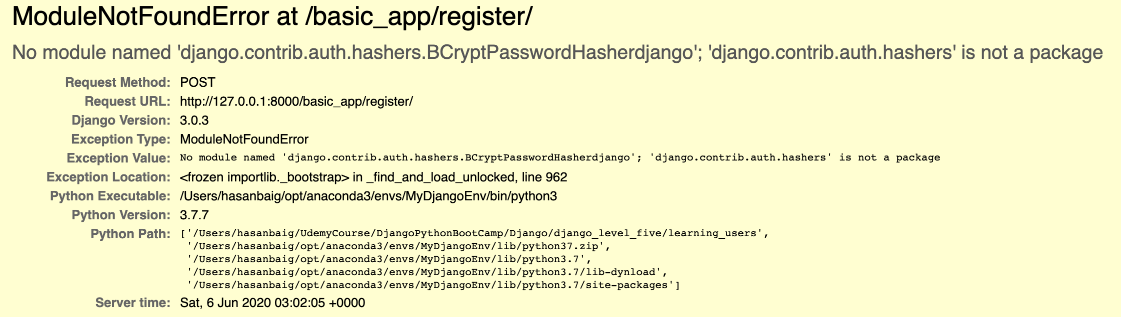

It turns out that the following library defined in settings.py file (line 93) was creating a problem.

'django.contrib.auth.hashers.BCryptPasswordHasher'

Commenting it out removed the error.

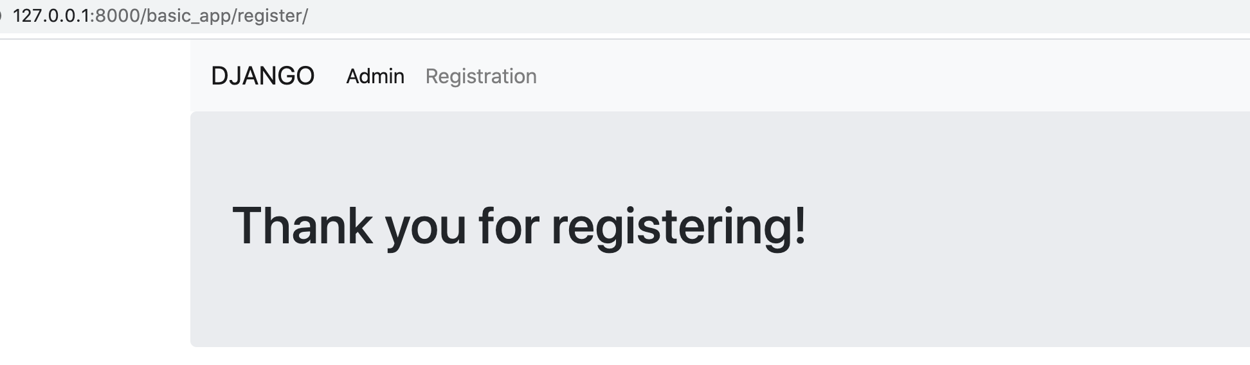

Create a superuser to login to admin. Login to admin and explore the registered users. Notice that the users passwords are not even visible to a Super User, which makes it secure for the user to make their passwords whatever they want.

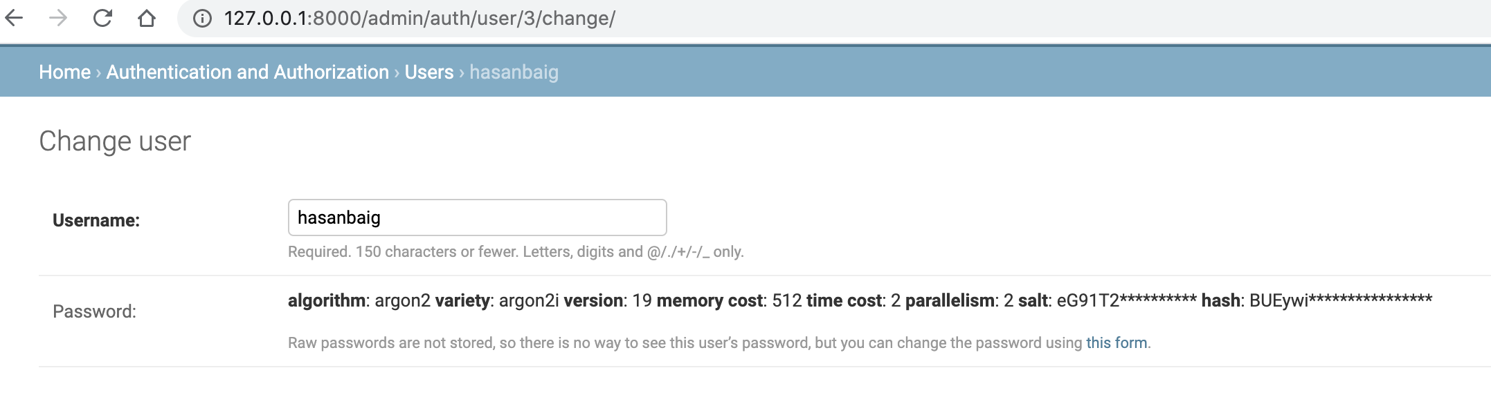

Now we were able to successfully register a user. The last thing we would want to do is to create a Login Page to let the registered user login and play around with the website resources they have an access to.

## Logins

Once a user is registered, we want to make sure that they can log in and out of the site. In this lecture we will go through the entire process of creating log in / log out functionality.

This process involves:

* Setting up the login views
* Using built-in decorators for access
* Adding the LOGIN_URL in settings
* Creating the login.html
* Editing the urls.py files

### Hands-on Practice

1. First set the URL variable at the very bottom in settings.py file, as shown below:

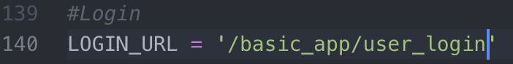

1. We now have to create a login.html file

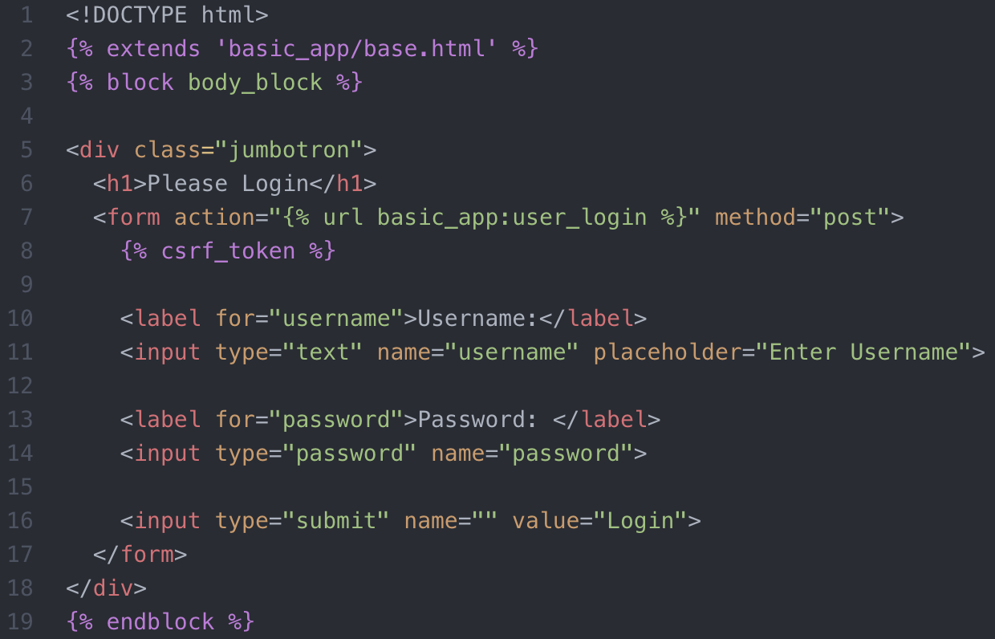

This is the first time you will see how we can play around with action= “as” in the form tag. We pass {% url basic_app:user_login %}. This will be discussed later on.

1. Now we have to add a menu item “Log In or Log Out” in the menu bar under base.html file, depending on if a user is logged in or logged out. So, in order to determine this, we need to create a logic in views.py file.

Go to views.py.

1. First, we need to import a lot of libraries because we will be using a lot of django’s built-in functionality.

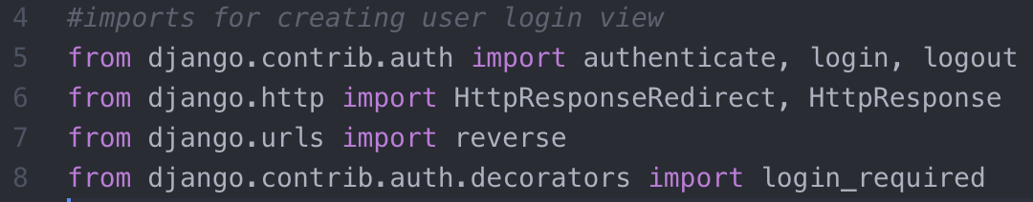

1. Now create a login view. We should name the method “login” or something similar to which we are already importing initially in the field. Doing so will overwrite the import methods.

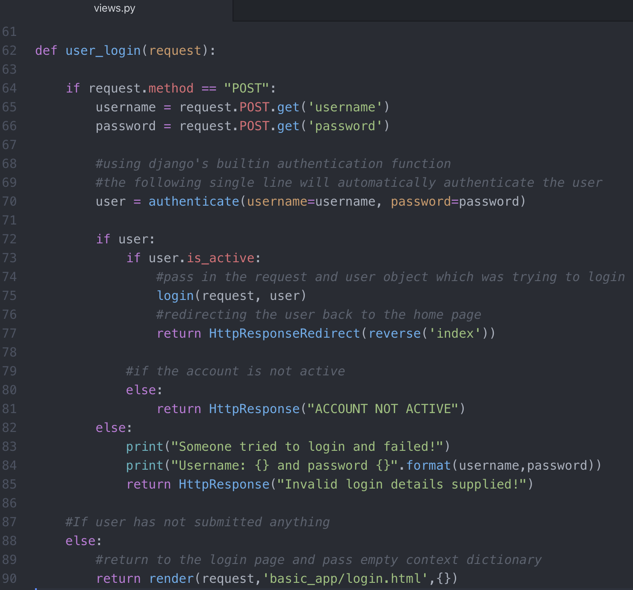

We would want to create new views that how a page would look like when a user logs out.

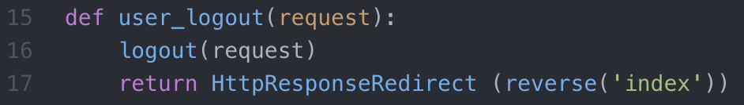

There is an issue in above view that we need to make sure that the user was already logged in, and the user get to view this only once he attempted to log out. Here comes the power of Django again. So, when we want some view to be seen only when a user is logged in, we can use the django’s built-in decorator “login_required” as shown below, which will enforce the view to be displayed only when the user is logged in.

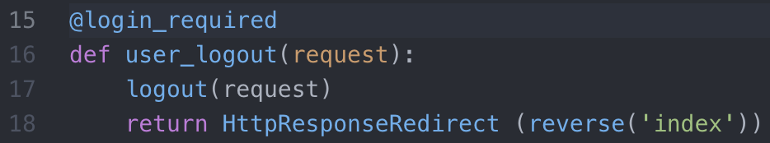

1. Now we need to point this view in urls.py file. So go to urls.py of the entire project.



1. Now come to the application’s urls.py file to point to the login url view.



1. Now come to base.html file and create a logic to add the “logout” or “login” page depending on if the user is already logged in or not.

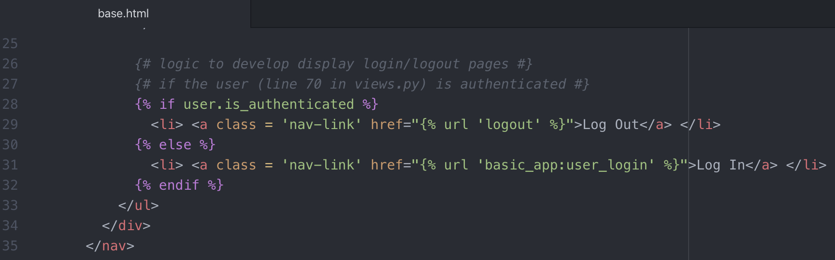

{% url 'logout' %} 🡪 logout is the page name defined in urls.py (under project dir) file.

**\*\*\*\*\*\*\*\*\*\*\*\*\*\*\*\*\*\*\*\*\*\*\*\*\*\*\*\*\*\* Django Level 5 Ends Here \*\*\*\*\*\*\*\*\*\*\*\*\*\*\*\*\*\*\*\*\*\*\*\*\*\*\*\*\*\*\***

**\*\*\*\*\*\*\*\*\*\*\*\*\*\*\*\*\*\*\*\*\*\*\*\*\*\*\*\*\*\*\*\* Django Deployment \*\*\*\*\*\*\*\*\*\*\*\*\*\*\*\*\*\*\*\*\*\*\*\*\*\*\*\*\*\*\***

**\*\*\*\*\*\*\*\*\*\*\*\*\*\*\*\*\*\*\*\*\*\*\*\*\*\*\*\*\*\*\*\*\*\*\*\*\*\*\*\*\*\*\*\*\*\*\*\*\*\*\*\*\*\*\*\*\*\*\*\*\*\*\*\*\*\*\*\*\*\*\*\*\*\*\*\*\*\*\*\*\*\*\*\*\*\*\*\***

Deploying to Python

<https://help.pythonanywhere.com/pages/DeployExistingDjangoProject/>

Deploying Python and Django Apps on Heroku

<https://devcenter.heroku.com/articles/deploying-python>

Deploying to Amazon Web Services

<https://docs.aws.amazon.com/elasticbeanstalk/latest/dg/create-deploy-python-django.html>

Deploying to Amazon Web Services

<https://docs.aws.amazon.com/elasticbeanstalk/latest/dg/create-deploy-python-django.html>

**\*\*\*\*\*\*\*\*\*\*\*\*\*\*\*\*\*\*\*\*\*\*\*\*\*\*\*\*\*\*\*\* Class-based Views \*\*\*\*\*\*\*\*\*\*\*\*\*\*\*\*\*\*\*\*\*\*\*\*\*\*\*\*\*\*\*\***

**\*\*\*\*\*\*\*\*\*\*\*\*\*\*\*\*\*\*\*\*\*\*\*\*\*\*\*\* Class-based Views Ends Here \*\*\*\*\*\*\*\*\*\*\*\*\*\*\*\*\*\*\*\*\*\*\*\*\*\*\***